**Sales and Inventory System**

**A PROJECT REPORT**

**Submitted By**

**Dharmendra Tomar**

**University Roll No 1900290149042**

**Submitted in partial fulfilment of the**

**Requirements for the Degree of**

**MASTER OF COMPUTER APPLICATION**

**Under the Supervision of**

**Ms. Neelam Rawat**

**KIET Group of Institution, Ghaziabad**



**to the**

**Department of Computer Applications**

**DR. APJ ABDUL KALAM TECHNICAL UNIVERSITY**

**(Formerly Uttar Pradesh Technical University) LUCKNOW**

**August 2021**

**DECLARATION**

I hereby declare that the work presented in this report entitled **“Sales And Inventory System",** was carried out by me. I have not submitted the matter embodied in this report for the award of any other degree or diploma of any other University or Institute.

I have given due credit to the original authors/sources for all the words, ideas, diagrams, graphics, computer programs, experiments, results, that are not my original contribution. I have used quotation marks to identify verbatim sentences and given credit to the original authors/sources.

I affirm that no portion of my work is plagiarized, and the experiments and results reported in the report are not manipulated. In the event of a complaint of plagiarism and the manipulation of the experiments and results, I shall be fully responsible and answerable.

**Name:** Dharmendra Tomar

**University Roll No:** 1900290149042

**Branch:** MCA

**(Candidate Signature):**

**Training Certificate**

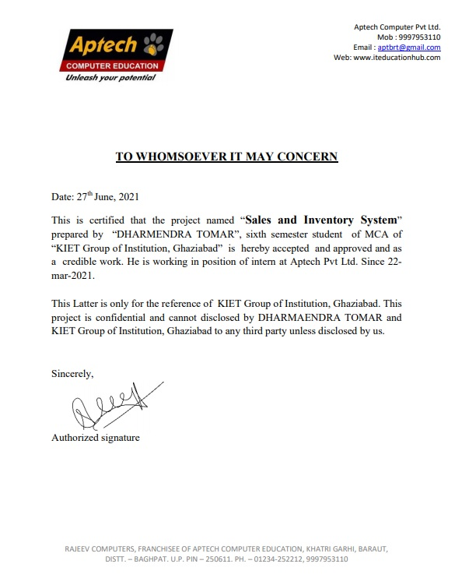

**CERTIFICATE**

Certified that **Dharmendra Tomar (Roll No. 1900290149042)**, have carried out the project work having **“Sales and Inventory System”** for **Master of Computer Applications** from Dr. A.P.J. Abdul Kalam Technical University (AKTU**)** (formerly UPTU), Technical University, Lucknow under the supervision of **Ms. Neelam Rawat**. The project report embodies original work, and studies are carried out by the student himself/herself and the contents of the project report do not form the basis for the award of any other degree to the candidate or to anybody else from this or any other University/Institution.

**Ms. Neelam Rawat External Examiner**

**Associate Professor**

**Department of Computer Applications**

**KIET Group of Institutions,**

**Ghaziabad**

**Dr. Ajay Kr. Shrivastava**

**Professor & Head**

**Department of Computer Applications**

**KIET Group of Institutions, Ghaziabad**

**Date:**

**ABSTRACT**

Abstract – The purpose of Sales and Inventory System is to automate the existing manual system by the help of computerized equipment’s and full-fledged computer software, fulfilling their requirements, so that their valuable data/information can be stored for a longer period with easy accessing and manipulation of the same. The required software and hardware are easily available and easy to work with.

Sales and Inventory System, as described above, can lead to error free, secure, reliable and fast management system. It can assist the user to concentrate on their other activities rather to concentrate on the record keeping. Thus, it will help organization in better utilization of resources. The organization can maintain computerized records without redundant entries. That means that one need not be distracted by information that is not relevant, while being able to reach the information.

The aim is to automate its existing manual system by the help of computerized equipment’s and full-fledged computer software, fulfilling their requirements, so that their valuable data/information can be stored for a longer period with easy accessing and manipulation of the same. Basically, the project describes how to manage for good performance and better services for the clients.

**ACKNOWLEDGEMENT**

I would like to express my special thanks of gratitude to my trainer **Mr. Sandeep Singh** as well as for her guidance, help and encouragement throughout my research work. Their enlightening ideas, comments, and suggestions.

My gratitude tomy other office colleges and seniors, for here administrative help at various occasions. I am thankful to them.

Secondly, I would also thanks to my parents, teachers, and friends who me helped a lot in finishing this project within a limited time. Without their support, completion of this work would not have been possible in time. They keep my life filled with enjoyment and happiness.

**Dharmendra Tomar**

**(1900290149042)**

**Table of Contents**

**Page No.**

**Declaration ii**

**Training Certificate iii**

**Certificate iv**

**Abstract v**

**Acknowledgement vi**

**List of Figure ix**

**CHAPTER 1 : INTRODUCTION 10-19**

1.1 Project Introduction 10

1.2 Project Abstract 11

1.3 Objective & Functionality 12

1.4 Scope of Project 13

1.5 Module & Report 14

1.6 Validation & Input Data 15

1.7 Feature of Project 16

1.8.1 SQA Strategy 17

1.8.2 SRS & Proposed System 17

1.9 Need of Identification 18-19

**CHAPTER 2 : SYSTEM STUDY 20-29**

2.1 Feasibility Study 20

2.2 Economical feasibility 21

2.3 Technical Feasibility 22

2.4 Operational Feasibility 23

2.5 Technology Used 24-29

**CHAPTER 3 : DESIGN 30-43**

3.1 System Design 30

3.2 User Interface Design 31-35

3.3 ER Diagrams 36-39

3.4 DFD 40-42

3.5 System Analysis 43

**CHAPTER 4 : CODDING & Screenshot 45 - 82**

**CHAPTER 5 : CONCLUSION & FUTURE SCOPE 83-88**

5.1Future Scope 83-84

5.2 Conclusion 85-86

5.3 Bibliography & References 87-88

**LIST OF FIGURE**

Page no.

Fig no. 1 (ER diagram of Inventory system) 37

Fig no. 2 (Zero Level DFD) 41

Fig no. 2 (Zero Level DFD) 42

Fig no. 4 (Login Page) 44

Fig no. 5 (Index Page) 48

Fig no. 6 (Inventory Page) 54

Fig no. 7 (Point of Sale) 57

Fig no. 8 (Product list) 62

Fig no. 9 (Supplier page) 67

Fig no. 10 (Transection Page) 73

Fig no. 11 (Customer List) 77

Fig no. 12 (Employee Detail) 81

**CHAPTER 1**

**INTRODUCTION**

**1.1 INTRODUCTION OF THE PROJECT SALES AND INVENTORY SYSTEM:**

The "Sales and Inventory System" has been developed to override the problems prevailing in the practicing manual system. This software is supported to eliminate and, in some cases, reduce the hardships faced by this existing system. Moreover, this system is designed for the particular need of the company to carry out operations in a smooth and effective manner.

The application is reduced as much as possible to avoid errors while entering the data. It also provides error message while entering invalid data. No formal knowledge is needed for the user to use this system. Thus, by this all it proves it is user-friendly. Inventory Management System, as described above, can lead to error free, secure, reliable and fast management system. It can assist the user to concentrate on their other activities rather to concentrate on the record keeping. Thus, it will help organization in better utilization of resources.

Every organization, whether big or small, has challenges to overcome and managing the information of Inventory, Stock, Sells, Product Category, Customers. Every Inventory Management System has different Stock needs; therefore, we design exclusive employee management systems that are adapted to your managerial requirements. This is designed to assist in strategic planning, and will help you ensure that your organization is equipped with the right level of information and details for your future goals. Also, for those busy executives who are always on the go, our systems come with remote access features, which will allow you to manage your workforce anytime, at all times. These systems will ultimately allow you to better manage resources.

**1.2 ABSTRACT OF THE PROJECT SALES AND INVENTORY SYSTEM:**

The purpose of Inventory Management System is to automate the existing manual system by the help of computerized equipment’s and full-fledged computer software, fulfilling their requirements, so that their valuable data/information can be stored for a longer period with easy accessing and manipulation of the same. The required software and hardware are easily available and easy to work with.

Inventory Management System, as described above, can lead to error free, secure, reliable and fast management system. It can assist the user to concentrate on their other activities rather to concentrate on the record keeping. Thus, it will help organization in better utilization of resources. The organization can maintain computerized records without redundant entries. That means that one need not be distracted by information that is not relevant, while being able to reach the information.

The aim is to automate its existing manual system by the help of computerized equipment’s and full-fledged computer software, fulfilling their requirements, so that their valuable data/information can be stored for a longer period with easy accessing and manipulation of the same. Basically, the project describes how to manage for good performance and better services for the clients.

**1.3 OBJECTIVE OF PROJECT ON SALES AND INVENTORY SYSTEM:**

The main objective of the Project on Inventory Management System is to manage the details of Stock, Inventory, Products, Sells, Customers. It manages all the information about Stock, Product Category, Customers, Stock. The project is totally built at administrative end and thus only the administrator is guaranteed the access. The purpose of the project is to build an application program to reduce the manual work for managing the Stock, Inventory, Product Category, Products.

**Functionalities provided by Inventory Management System are as follows:**

* Provides the searching facilities based on various factors. Such as Stock, Products, Sells, Customers
* Inventory Management System also manage the Product Category details online for Sells details, Customers details, Stock.
* Editing, adding and updating of Records is improved which results in proper resource management of Stock data.
* Manage the information of Sells
* Integration of all records of Customers.
* It tracks all the information of Inventory, Product Category, Sells ect
* Manage the information of Inventory
* Shows the information and description of the Stock, Products
* To increase efficiency of managing the Stock, Inventory
* It deals with monitoring the information and transactions of Sells.
* Manage the information of Stock

**1.4 SCOPE OF THE PROJECT SALES AND INVENTORY SYSTEM:**

It may help collecting perfect management in details. In a very short time, the collection will be obvious, simple and sensible. It will help a person to know the management of passed year perfectly and vividly. It also helps in current all works relative to Inventory Management System. It will be also reduced the cost of collecting the management & collection procedure will go on smoothly. Our project aims at Business process automation, i.e., we have tried to computerize various processes of Inventory Management System.

* In computer system the person has to fill the various forms & number of copies of the forms can be easily generated at a time.
* In computer system, it is not necessary to create the manifest but we can directly print it, which saves our time.
* To assist the staff in capturing the effort spent on their respective working areas.
* To utilize resources in an efficient manner by increasing their productivity through automation.
* The system generates types of information that can be used for various purposes.
* It satisfies the user requirement
* Be easy to understand by the user and operator
* Be easy to operate
* Have a good user interface
* Be expandable
* Delivered on schedule within the budget.

**1.5 REPORTS OF SALES AND INVENTORY SYSTEM :**

* It generates the report on Stock, Inventory, Product Category
* Provide filter reports on Products, Sells, Customers
* You can easily export PDF for the Stock, Product Category, Sells
* Application also provides excel export for Inventory, Products, Customers
* You can also export the report into csv format for Stock, Inventory, Customers

**1.5 MODULES OF SALES AND INVENTORY SYSTEM:**

* Stock Management Module: Used for managing the Stock details.
* Customers Module: Used for managing the details of Customers
* Product Category Module: Used for managing the details of Product Category
* Inventory Management Module: Used for managing the information and details of the Inventory.
* Products Module: Used for managing the Products details
* Sells Module: Used for managing the Sells information’s
* Login Module: Used for managing the login details
* Users Module: Used for managing the users of the system

**1.6 INPUT DATA AND VALIDATION OF PROJECT ON SALES AND INVENTORY SYSTEM :**

* All the fields such as Stock, Products, Customers are validated and does not take invalid values
* Each form for Stock, Inventory, Product Category cannot accept blank value fields
* Avoiding errors in data
* Controlling amount of input
* Integration of all the modules/forms in the system.
* Preparation of the test cases.
* Preparation of the possible test data with all the validation checks.
* Actual testing done manually.
* Recording of all the reproduced errors.
* Modifications done for the errors found during testing.
* Prepared the test result scripts after rectification of the errors.
* Functionality of the entire module/forms.
* Validations for user input.
* Checking of the Coding standards to be maintained during coding.
* Testing the module with all the possible test data.
* Testing of the functionality involving all type of calculations etc.
* Commenting standard in the source files.

**1.7 FEATURES OF THE PROJECT SALES AND INVENTORY SYSTEM:**

* Creating & Changing Issues at ease
* Query Issue List to any depth
* Repo Product and Component based
* rating & Charting in more comprehensive way
* User Accounts to control the access and maintain security
* Simple Status & Resolutions
* Multi-level Priorities & Severities.
* Targets & Milestones for guiding the programmers
* Attachments & Additional Comments for more information
* Robust database back-end
* Various level of reports available with a lot of filter criteria’s
* It contains better storage capacity.
* Accuracy in work.
* Easy & fast retrieval of information.
* Well-designed reports.
* Decrease the load of the person involve in existing manual system.
* Access of any information individually.
* Work becomes very speedy.
* Easy to update information

**1.8.1 SOFTWARE QUALITY PLAN WE WILL USE THE FOLLOWING SQA STRATEGY:**

* In the first step, we will select the test factors and rank them. The selected test factors such as reliability, maintainability, portability or etc. will be placed in the matrix according to their ranks.
* The second step is for identifying the phases of the development process.
* The phase should be recorded in the matrix.
* The third step is that identifying the business risks of the software deliverables.
* The risks will be ranked into three ranks such as high, medium and low.

**1.8.2 SOFTWARE REQUIREMENT SPECIFICATION**

The Software Requirements Specification is produced at the culmination of the analysis task. The function and performance allocated to software as part of system engineering are refined by establishing a complete information description, a detailed functional and behavioural description, an indication of performance requirements and design constraints, appropriate validation criteria, and other data pertinent to requirements.

**The proposed system has the following requirements:**

* System needs store information about new entry of Stock.
* System needs to help the internal staff to keep information of Inventory and find them as per various queries.
* System needs to maintain quantity record.
* System needs to keep the record of Products.
* System needs to update and delete the record.
* System also needs a search area.
* It also needs a security system to prevent data.

**1.9 NEED OF IDENTIFICATION :**

The old manual system was suffering from a series of drawbacks. Since whole of the system was to be maintained with hands the process of keeping, maintaining and retrieving the information was very tedious and lengthy. The records were never be used to be in a systematic order so there are used to be lots of difficulties in their associating any particular Partner transaction with a particular context.

If any information was to be found it was required to go through the different registers, documents there would never exist anything like report generation. There would always be unnecessary consumption of time while entering records and retrieving records. One more problem was that it was very difficult to find errors while entering the records. Once the records were entered it was very difficult to update these records.

The reason behind it is that there is lot of information to be maintained and have to be kept in mind while running the business. For this reason, we have provided features Present system is partially automated (computerized), actually existing system is quite laborious as one has to enter same information at three different places.

**Following points should be well considered:**

* Documents and reports that must be provided by the new system: there can also be few reports, which can help management in decision-making and cost controlling.
* These reports do not get required attention, such kind of reports and information were also identified and given required attention.
* Details of the information needed for each document and report.
* The required frequency and distribution for each document.
* Probable sources of information for each document and report.
* With the implementation of computerized system, the task of keeping records in an organized manner will be solved.
* The greatest of all is the retrieval of information, which will be at the click of the mouse.
* So, the proposed system helps in saving the time in different operations and making information flow easy giving valuable reports.

**CHAPTER 2**

**SYSTEM STUDY**

**2.1 FEASIBILITY STUDY:**

After doing the project Sales and Inventory Management System, study and analysing all the existing or required functionalities of the system, the next task is to do the feasibility study for the project. All projects are feasible - given unlimited resources and infinite time. Feasibility study includes consideration of all the possible ways to provide a solution to the given problem. The proposed solution should satisfy all the user requirements and should be flexible enough so that future changes can be easily done based on the future upcoming requirements. The initial investigation points to the question whether the project is feasible. A feasibility is conducted to identify the best system that meets the all the requirements.

This includes an identification description, a valuation of the proposed systems and selection of the best system for the job. The requirements of the system are specified with a set of constraints such as system objectives and the description of the out puts. It is then duty of the analyst to evaluate the feasibility of the proposed system to generate the above results. Whatever we think need not be feasible .It is wise to think about the feasibility of any problem we undertake.

Feasibility is the study of impact, which happens in the organization by the development of a system. The impact can be either positive or negative. When the positives nominate the negatives, then the system is considered feasible. Here the feasibility study can be performed in three ways such as technical feasibility, Economical Feasibility and Operational Feasibility.

**2.2 ECONOMIC FEASIBILITY:**

This is a very important aspect to be considered while developing a project. We decided the technology based on minimum possible cost factor. All hardware and software cost has to be borne by the organization. Overall, we have estimated that the benefits the organization is going to receive from the proposed system will surely overcome the initial costs and the later on running cost for system.

Economic feasibility is the most important and frequently used method for evaluating the effectiveness of the proposed system. It is very essential because the main goal of the proposed system is to have economically better result along with increased efficiency. Cost benefit analysis is usually performed for this purpose. It is the comparative study of the cost verses the benefit and savings that are expected from the proposed system. Since the organization is well equipped with the required hard ware, the project was found to be economically.

Development of this application is highly economically feasible .The organization needed not spend much money for the development of the system already available. The only thing is to be done is making an environment for the development with an effective supervision. If we are doing so, we can attain the maximum usability of the corresponding resources. Even after the development , the organization will not be in condition to invest more in the organization. Therefore, the system is economically feasible.

**2.3 Technical Feasibility:**

This included the study of function, performance and constraints that may affect the ability to achieve an acceptable system. For this feasibility study, we studied complete functionality to be provided in the system, as described in the System Requirement Specification (SRS), and checked if everything was possible using different type of frontend and backend platforms. We can strongly say that it is technically feasible, since there will not be much difficulty in getting required resources for the development and maintaining the system as well.

All the resources needed for the development of the software as well as the maintenance of the same is available in the organization here we are utilizing the resources which are available already. The main consideration is to be given to the study of available resources of the organization where the software is to be implemented. Here the system analyst evaluates the technical merits of the system giving emphasis on the performance, Reliability, maintainability and productivity. By taking the consideration before developing the proposed system, the resources availability of the organization was studied. The organization was immense computer facilities equipped with sophisticated machines and the software hence this technically feasible.

**2.4 OPERATIONAL FEASIBILITY:**

No doubt the proposed system is fully GUI based that is very user friendly and all inputs to be taken all self-explanatory even to a layman. Besides, a proper training has been conducted to let know the essence of the system to the users so that they feel comfortable with new system. As far our study is concerned the clients are comfortable and happy as the system has cut down their loads and doing.

An estimate should be made to determine how much effort and care will go into the developing of the system including the training to be given to the user. Usually, people are reluctant to changes that come in their progression. The computer initialization will certainly affected the turn over, transfer and employee job status. Hence an additional effort is to be made to train and educate the users on the new way of the system.

…

**2.5** **TECHNOLOGY USED:**

**PHP**

PHP: Hypertext Pre-processor, is a widely used, general-purpose [scripting language](http://en.wikipedia.org/wiki/Scripting_language) that was originally designed for [web development](http://en.wikipedia.org/wiki/Web_development), to produce [dynamic web pages](http://en.wikipedia.org/wiki/Dynamic_web_page). It can be embedded into [HTML](http://en.wikipedia.org/wiki/HTML) and generally runs on a [web server](http://en.wikipedia.org/wiki/Web_server), which needs to be configured to process PHP code and create [web page](http://en.wikipedia.org/wiki/Web_page) content from it. It can be deployed on most web servers and on almost every [operating system](http://en.wikipedia.org/wiki/Operating_system) and [platform](http://en.wikipedia.org/wiki/Platform_(computing)) free of charge.

PHP was originally created by [Ramus Lerdorf](http://en.wikipedia.org/wiki/Rasmus_Lerdorf) in [1995](http://en.wikipedia.org/wiki/1995) and has been in continuous development ever since. The main implementation of PHP is now produced by The PHP Group and serves as the [de facto standard](http://en.wikipedia.org/wiki/De_facto_standard) for PHP as there is no [formal specification](http://en.wikipedia.org/wiki/Formal_specification). PHP is [free software](http://en.wikipedia.org/wiki/Free_software) released under the [PHP License](http://en.wikipedia.org/wiki/PHP_License), which is incompatible with the [GNU General Public License](http://en.wikipedia.org/wiki/GNU_General_Public_License) (GPL) because of restrictions on the use of the term PHP. PHP has evolved to include a [command line interface](http://en.wikipedia.org/wiki/Command_line_interface) capability and can also be used in [standalone](http://en.wikipedia.org/wiki/Standalone_software) [graphical applications](http://en.wikipedia.org/wiki/Graphical_user_interface).

**USAGE**

PHP is a general-purpose scripting language that is especially suited for [web development](http://en.wikipedia.org/wiki/Web_development). PHP generally runs on a [web server](http://en.wikipedia.org/wiki/Web_server). Any PHP code in a requested file is [executed](http://en.wikipedia.org/wiki/Execution_(computing)) by the PHP runtime, usually to create [dynamic web page](http://en.wikipedia.org/wiki/Dynamic_web_page) content. It can also be used for [command-line](http://en.wikipedia.org/wiki/Command-line) scripting and [client-side](http://en.wikipedia.org/wiki/Client-side) [GUI](http://en.wikipedia.org/wiki/Graphical_user_interface) applications. PHP can be deployed on most [web servers](http://en.wikipedia.org/wiki/Web_server), many [operating systems](http://en.wikipedia.org/wiki/Operating_system) and [platforms](http://en.wikipedia.org/wiki/Platform_(computing)), and can be used with many [relational database management systems](http://en.wikipedia.org/wiki/Relational_database_management_system). It is available free of charge, and the PHP Group provides the complete source code for users to build, customize and extend for their own use.

PHP primarily acts as a [filter](http://en.wikipedia.org/wiki/Filter_(software)), taking input from a file or stream containing text and/or PHP instructions and outputs another stream of data; most commonly the output will be HTML. Since PHP 4, the PHP [parser](http://en.wikipedia.org/wiki/Parser) [compiles](http://en.wikipedia.org/wiki/Compiler) input to produce [byte code](http://en.wikipedia.org/wiki/Bytecode) for processing by the [Zend Engine](http://en.wikipedia.org/wiki/Zend_Engine), giving improved performance over its [interpreter](http://en.wikipedia.org/wiki/Interpreter_(computing)) predecessor

Originally designed to create dynamic web pages, PHP now focuses mainly on [server-side scripting](http://en.wikipedia.org/wiki/Server-side_scripting), and it is similar to other server-side scripting languages that provide dynamic content from a web server to a [client](http://en.wikipedia.org/wiki/Client_(computing)), such as [Microsoft](http://en.wikipedia.org/wiki/Microsoft)'s [Active Server Pages](http://en.wikipedia.org/wiki/Active_Server_Pages), [Sun Microsystems](http://en.wikipedia.org/wiki/Sun_Microsystems)' [Java Server Pages](http://en.wikipedia.org/wiki/JavaServer_Pages) and [mode_perl](http://en.wikipedia.org/wiki/Mod_perl). PHP has also attracted the development of many [frameworks](http://en.wikipedia.org/wiki/Software_framework) that provide building blocks and a design structure to promote [rapid application development](http://en.wikipedia.org/wiki/Rapid_application_development) (RAD). Some of these include [Cake PHP](http://en.wikipedia.org/wiki/CakePHP), [Symphony](http://en.wikipedia.org/wiki/Symfony), [CodeIgniter](http://en.wikipedia.org/wiki/CodeIgniter), and [Zend Framework](http://en.wikipedia.org/wiki/Zend_Framework), offering features similar to other [web application frameworks](http://en.wikipedia.org/wiki/List_of_web_application_frameworks).

**About HTML**

**HTML**, which stands for **Hyper Text Markup Language**, is the predominant [markup language](http://en.wikipedia.org/wiki/Markup_language) for [web pages](http://en.wikipedia.org/wiki/Web_page). It provides a means to create [structured documents](http://en.wikipedia.org/wiki/Structured_document) by denoting structural [semantics](http://en.wikipedia.org/wiki/Semantic) for text such as headings, paragraphs, lists etc. as well as for links, quotes, and other items. It allows [images and objects](http://en.wikipedia.org/wiki/HTML_element#Images_and_objects) to be embedded and can be used to create [interactive forms](http://en.wikipedia.org/wiki/HTML_element#Forms). It is written in the form of [HTML elements](http://en.wikipedia.org/wiki/HTML_element) consisting of "tags" surrounded by [angle brackets](http://en.wikipedia.org/wiki/Brackets#Angle_brackets_or_chevrons_.3C_.3E) within the web page content. It can include or can load [scripts](http://en.wikipedia.org/wiki/Scripting_language) in languages such as [JavaScript](http://en.wikipedia.org/wiki/JavaScript) which affect the behaviour of HTML processors like [Web browsers](http://en.wikipedia.org/wiki/Web_browser); and [Cascading Style Sheets](http://en.wikipedia.org/wiki/Cascading_Style_Sheets) (CSS) to define the appearance and layout of text and other material. The [W3C](http://en.wikipedia.org/wiki/W3C), maintainer of both HTML and CSS standards, encourages the use of CSS over explicit presentational mark up.

Hyper Text Markup Language(HTML) is the encoding scheme used to create and format a web document. A user need not be an expert programmer to make use of HTML for creating hypertext documents that can be put on the internet. Most graphical [e-mail](http://en.wikipedia.org/wiki/E-mail) clients allow the use of a subset of HTML (often ill-defined) to provide formatting and [semantic](http://en.wikipedia.org/wiki/Semantic_web) markup not available with [plain text](http://en.wikipedia.org/wiki/Plain_text). This may include typographic information like coloured headings, emphasized and quoted text, inline images and diagrams. Many such clients include both a [GUI](http://en.wikipedia.org/wiki/GUI) editor for composing HTML e-mail messages and a rendering engine for displaying them. Use of HTML in e-mail is controversial because of compatibility issues, because it can help disguise [phishing](http://en.wikipedia.org/wiki/Phishing) attacks, because it can confuse [spam](http://en.wikipedia.org/wiki/E-Mail_spam) filters and because the message size is larger than plain text.

**NAMING CONVENTIONS**

The most common [filename extension](http://en.wikipedia.org/wiki/Filename_extension) for [files](http://en.wikipedia.org/wiki/Computer_file) containing HTML is .html. A common abbreviation of this is .html, which originated because some early operating systems and file systems, such as [DOS](http://en.wikipedia.org/wiki/DOS) and [FAT](http://en.wikipedia.org/wiki/File_Allocation_Table), limited file extensions to [three letters](http://en.wikipedia.org/wiki/8.3_filename).

**HTML APPLICATION**

An HTML Application is a [Microsoft Windows](http://en.wikipedia.org/wiki/Microsoft_Windows) application that uses HTML and Dynamic HTML in a browser to provide the application's graphical interface. A regular HTML file is confined to the security model of the web browser, communicating only to web servers and manipulating only webpage objects and [site cookies](http://en.wikipedia.org/wiki/HTTP_cookie). An HTA runs as a fully trusted application and therefore has more privileges, like creation/editing/removal of files and [Windows Registry](http://en.wikipedia.org/wiki/Windows_Registry) entries. Because they operate outside the browser's security model, HTAs cannot be executed via HTTP, but must be downloaded (just like an [EXE file](http://en.wikipedia.org/wiki/EXE)) and executed from local file system

**ABOUT JAVASCRIPT**

**JavaScript** is an [object-oriented](http://en.wikipedia.org/wiki/Object-oriented) [scripting language](http://en.wikipedia.org/wiki/Scripting_language) used to enable [programmatic](http://en.wikipedia.org/wiki/Computer_programming) access to objects within both the [client application](http://en.wikipedia.org/wiki/Client_(computing)) and other [applications](http://en.wikipedia.org/wiki/Application_software). It is primarily used in the form [client-side JavaScript](http://en.wikipedia.org/wiki/Client-side_JavaScript), implemented as an integrated component of [web browser](http://en.wikipedia.org/wiki/Web_browser), allowing the development of enhanced [user interfaces](http://en.wikipedia.org/wiki/User_interface) and dynamic [websites](http://en.wikipedia.org/wiki/Website). JavaScript is a [dialect](http://en.wikipedia.org/wiki/Programming_language_dialect) of the [Script](http://en.wikipedia.org/wiki/ECMAScript) standard and is characterized as a [dynamic](http://en.wikipedia.org/wiki/Dynamic_language), [weakly typed](http://en.wikipedia.org/wiki/Weak_typing), [prototype-based](http://en.wikipedia.org/wiki/Prototype-based_programming) language with [first-class functions](http://en.wikipedia.org/wiki/First-class_function). JavaScript was influenced by many languages and was designed to look like [Java](http://en.wikipedia.org/wiki/Java_(programming_language)), but easier for non-programmers to work with.

**PROTOTYPE-BASED**

JavaScript uses [prototypes](http://en.wikipedia.org/wiki/Prototype-based_programming) instead of [classes](http://en.wikipedia.org/wiki/Class_(computer_science)) for [inheritance](http://en.wikipedia.org/wiki/Inheritance_(computer_science)). It is possible to simulate many class-based features with prototypes in JavaScript. Functions double as object constructors along with their typical role. Prefixing a function call with new creates a new object and calls that function with its local this keyword bound to that object for that invocation. The constructor's prototype property determines the object used for the new object's internal prototype. JavaScript's built-in constructors, such as Array, also have prototypes that can be modified.

Unlike many object-oriented languages, there is no distinction between a function definition and a [method](http://en.wikipedia.org/wiki/Method_(computer_science)) definition. Rather, the distinction occurs during function calling; a function can be called as a method. When a function is called as a method of an object, the function's local this keyword is bound to that object for that invocation.

**USAGE**

The primary use of JavaScript is to write functions that are embedded in or included from [HTML](http://en.wikipedia.org/wiki/HTML) pages and interact with the [Document Object Model](http://en.wikipedia.org/wiki/Document_Object_Model) (DOM) of the page. Because JavaScript code can run locally in a user's browser (rather than on a remote server) it can respond to user actions quickly, making an application feel more responsive. Furthermore, JavaScript code can detect user actions which HTML alone cannot, such as individual keystrokes. Applications such as [Gmail](http://en.wikipedia.org/wiki/Gmail) take advantage of this: much of the user-interface logic is written in JavaScript, and JavaScript dispatches requests for information (such as the content of an e-mail message) to the server. The wider trend of [Ajax programming](http://en.wikipedia.org/wiki/AJAX) similarly exploits this strength.

A [JavaScript engine](http://en.wikipedia.org/wiki/JavaScript_engine) (also known as *JavaScript interpreter* or *JavaScript implementation*) is an [interpreter](http://en.wikipedia.org/wiki/Interpreter_(computing)) that interprets JavaScript [source code](http://en.wikipedia.org/wiki/Source_code) and executes the [script](http://en.wikipedia.org/wiki/Computer_program) accordingly. The first JavaScript engine was created by [Brendan Each](http://en.wikipedia.org/wiki/Brendan_Eich) at Netscape Communications Corporation, for the [Netscape Navigator](http://en.wikipedia.org/wiki/Netscape_Navigator) [web browser](http://en.wikipedia.org/wiki/Web_browser). A web browser is by far the most common host environment for JavaScript. Web browsers typically use the public [API](http://en.wikipedia.org/wiki/Application_programming_interface) to create "host objects" responsible for reflecting the [DOM](http://en.wikipedia.org/wiki/Document_Object_Model) into JavaScript.

## MySQL Introduction

There are a large number of database management systems currently available and some are free. Some of them : Oracle, Microsoft Access, MySQL. These database systems are powerful, feature-rich software, capable of organizing and searching millions of records at very high speeds. Understanding Databases, Records.

Primary Keys

Every Database is composed of one or more tables.  
These Tables, which structure data into rows and columns, Impose organization on the data. The records in a table(below) are not arranged in any particular order. To make it easy to identify a specific record, therefore, it becomes necessary.

### Standing Relationships and Foreign Keys (RDBMS)

You already know that a single database can hold multiple tables.  
In a Relational database management system(RDBMS), these tables can be linked to each other by one or more common fields, called **foreign keys**.

### What is Database administrator (DBA) ?

Database administrator is the super user of database, he has unrestricted rights and privileges to access database, grant permission to other database users.

### What is Database user (DBU) ?

Database user is the person who uses the database in a restricted privileges, provided by database administrator. Download MySQL Database If you have installed PHP’s WAMP or XAMPP server, then mysql database already exists. if you don’t have then download mysql database from here [http://www.mysql.com](http://www.phptpoint.com/mysql/)

**CHAPTER 3**

**DESIGN**

**3.1 SYSTEM DESIGN OF SALES AND INVENTORY SYSTEM**

In this phase, a logical system is built which fulfils the given requirements. Design phase of software development deals with transforming the client’s requirements into a logically working system. Normally, design is performed in the following in the following two steps:

* **Primary Design Phase:**

In this phase, the system is designed at block level. The blocks are created on the basis of analysis done in the problem identification phase. Different blocks are created for different functions emphasis is put on minimising the information flow between blocks. Thus, all activities which require more interaction are kept in one block.

* **Secondary Design Phase:**

In the secondary phase the detailed design of every block is performed.

**The general tasks involved in the design process are the following:**

* Design various blocks for overall system processes.
* Design smaller, compact and workable modules in each block.
* Design various database structures.
* Specify details of programs to achieve desired functionality.
* Design the form of inputs, and outputs of the system.
* Perform documentation of the design.

**3.2 USER INTERFACE DESIGN**

User Interface Design is concerned with the dialogue between a user and the computer. It is concerned with everything from starting the system or logging into the system to the eventually presentation of desired inputs and outputs. The overall flow of screens and messages is called a dialogue.

**The following steps are various guidelines for User Interface Design:**

* The system user should always be aware of what to do next.
* The screen should be formatted so that various types of information, instructions and messages always appear in the same general display area.
* Message, instructions or information should be displayed long enough to allow the system user to read them.
* Use display attributes sparingly.
* Default values for fields and answers to be entered by the user should be specified.
* A user should not be allowed to proceed without correcting an error.
* The system user should never get an operating system message or fatal error.

**Preliminary Product Description:**

The first step in the system development life cycle is the preliminary investigation to determine the feasibility of the system. The purpose of the preliminary investigation is to evaluate project requests. It is not a design study nor does it include the collection of details to describe the business system in all respect. Rather, it is the collecting of information that helps committee members to evaluate the merits of the project request and make an informed judgment about the feasibility of the proposed project.

**Analysts working on the preliminary investigation should accomplish the following objectives:**

* Clarify and understand the project request
* Determine the size of the project.
* Assess costs and benefits of alternative approaches.
* Determine the technical and operational feasibility of alternative approaches.
* Report the findings to management, with recommendations outlining the acceptance or rejection of the proposal.

**Benefit to Organization**

The organization will obviously be able to gain benefits such as savings in operating cost, reduction in paperwork, better utilization of human resources and more presentable image increasing goodwill.

**The Initial Cost**

The initial cost of setting up the system will include the cost of hardware software (OS, add-on software, utilities) & labour (setup & maintenance). The same has to bear by the organization.

**Running Cost**

Besides, the initial cost the long-term cost will include the running cost for the system including the AMC, stationary charges, cost for human resources, cost for update/renewal of various related software.

**Need for Training**

The users along with the administrator need to be trained at the time of implementation of the system for smooth running of the system. The client will provide the training site. We talked to the management people who were managing the financial issues of the centre, the staff who were keeping the records in lots of registers and the reporting manager regarding their existing system, their requirements and their expectations from the new proposed system. Then, we did the system study of the entire system based on their requirements and the additional features they wanted to incorporate in this system.

Reliable, accurate and secure data was also considered to be a complex task without this proposed system. Because there was no such record for keeping track of all the activities, which was done by the Inventory Management System on the daily basis. The new system proposed and then developed by me will ease the task of the organization in consideration. It will be helpful in generating the required reports by the staff, which will help them to track their progress and services.

Thus, it will ease the task of Management to a great extent as all the major activities to be performed, are computerized through this system.

**Project Category**

Relational Database Management System (RDBMS) : This is an RDBMS based project which is currently using MySQL for all the transaction statements. MySQL is an open source RDBMS System.

**Brief Introduction about RDBMS:**

A relational database management system (RDBMS) is a database management system (DBMS) that is based on the relational model as invented by E. F. Codd, of IBM's San Jose Research Laboratory. Many popular databases currently in use are based on the relational database model.

RDBMSs have become a predominant choice for the storage of information in new databases used for financial records, manufacturing and logistical information, personnel data, and much more since the 1980s. Relational databases have often replaced legacy hierarchical databases and network databases because they are easier to understand and use. However, relational databases have been challenged by object databases, which were introduced in an attempt to address the object-relational impedance mismatch in relational database, and XML databases.

**Implementation Methodology:**

Model View Controller or MVC as it is popularly called, is a software design pattern for developing web applications. A Model View Controller pattern is made up of the following three parts:

* **Model** - The lowest level of the pattern which is responsible for maintaining data.
* **View** - This is responsible for displaying all or a portion of the data to the user.
* **Controller** - Software Code that controls the interactions between the Model and View.

MVC is popular as it isolates the application logic from the user interface layer and supports separation of concerns. Here the Controller receives all requests for the application and then works with the Model to prepare any data needed by the View. The View then uses the data prepared by the Controller to generate a final presentable response. The MVC abstraction can be graphically represented as follows.

**3.3 ER - DIAGRAM**

The ER diagram of **Inventory Management System** shows all the visual instrument of database tables and the relations between Customer, Stock, Inventory, Supplier etc. It used structure data and to define the relationships between structured data groups of **Inventory Management System** functionalities. Here we will discuss the step by step process on how to prepare the entity relationship diagram or ERD of the project entitled Sales and Inventory System ER Diagram.

The project entitled Sales and Inventory System is a database system that organizes and manages the sales transactions as well as the inventory of stocks, products or items. The first step in the development of the Sales and Inventory System ER Diagram is to prepare the ER diagram that will serve as the basis later on in the creation of the actual database. We will create and explain the process of making the entity relationship diagram of Sales and Inventory System ER Diagram.

**Let’s start from the symbols used in the ER Diagram.**

Entity is represented by the rectangle shape. The entity will be our database table of Sales and Inventory System ER Diagram later on.

Attribute is represented by the oval shape. This will be the columns or fields of each table in the Sales and Inventory System ER Diagram.

Relationship is represented by diamond shape. This will determine the relationships among entities. This is usually in a form of primary key to foreign key connection.

We will follow the 3 basic rules in creating the ER Diagram.

1. Identify all the entities.
2. Identify the relationship between entities and
3. Add meaningful attributes to our entities.

**Step 1**. In the Sales and Inventory System ER Diagram we have the following entities

* User Information
* Product
* Item Raw Material
* Unit
* Category
* Sales
* Invoice

Our design of Sales and Inventory System ER Diagram consists of 7 entities; the specified entities will be our database tables in the design and implementation of Sales and Inventory System ER Diagram database schema. We will now draw the entities of the Sales and Inventory System ER Diagram specified above and it will be represented by a rectangle shape. The image below is the entities identified in the scope of the Sales and Inventory System ER Diagram.

**Step 2**. After we have specified our entities, it is time now to connect or establish a relationship among the entities.

* The user encode/manage/update the product information (1 to many relationship). The user type that can manage the customer info is admin and encoder the type.
* The user encode/manage/update the unit information (1 to many relationship). The user type that can manage the customer info is the admin and encoder type.
* The user encode/manage/update the product category information (1 to many relationship). The user type that can manage the customer info is the admin and encoder type.
* The user encode/manage/update the item raw material information (1 to many relationship). The user type that can manage the customer info is the admin and encoder type.
* The product can contain 1 or more raw materials (1 to many relationship).
* Product information may have 1 or more unit, for example, the product may be sold in piece, dozen, box, etc. (1 to many relationship).
* A product belongs to a specific category (1 to 1 relationship).
* Sale transactions includes 1 or more products (1 to many relationship). The user type that can manage the customer info is admin and cashier the type.

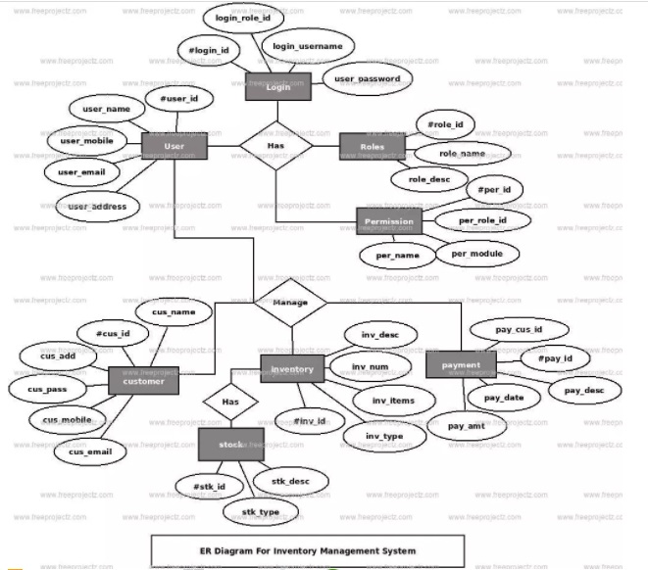

**Fig no. 1 (ER diagram of Inventory system)**

**Step 3**. The last part of the ERD process is to add attributes to our entities.

User Information Entity has the following attributes:

* ID – primary key represented with underline
* Full name
* Contact
* Address
* Username
* Password
* User Type

Product Entity has the following attributes:

* ID – primary key represented with underline
* Item Code
* Item Name
* Variant
* Unit Value
* Unit ID – foreign key
* Category ID –foreign key
* Net Price
* Production Cost
* Mark up Price
* Mark up Percentage
* Discount
* Discount Price
* Sales Price
* Reorder Level
* Stocks Quantity
* Expiry Date
* User ID – foreign key
* Date Encoded

Item Raw Material Entity has the following attributes:

* ID – primary key represented with underline
* Product ID –foreign name
* Material Name
* Amount
* Date Encoded
* User ID – foreign key

Unit Entity has the following attributes:

* ID – primary key represented with underline
* Name
* Description
* User ID – foreign key
* Date Encoded

Category Entity has the following attributes:

* ID – primary key represented with underline
* Name
* Description
* User ID – foreign key
* Date Encoded

Sales Entity has the following attributes:

* ID – primary key represented with underline
* Item ID – foreign key
* OR ID
* Sales Quantity
* Total
* User ID
* Date Recorded

Invoice Entity has the following attributes:

* ID – primary key represented with underline
* User ID
* Total Amount
* Discount Price
* Tendered
* Change
* Date Recorded

**Note: all attributes with underline represents the primary key of the entity or table.**

**3.4 DATA FLOW DIAGRAM:**

The DFD takes an input-process-output view of a system i.e. data objects flow into the software, are transformed by processing elements, and resultant data objects flow out of the software. Data objects represented by labelled arrows and transformation are represented by circles also called as bubbles. DFD is presented in a hierarchical fashion i.e. the first data flow model represents the system as a whole. Subsequent DFD refine the context diagram (level 0 DFD), providing increasing details with each subsequent level.

The DFD enables the software engineer to develop models of the information domain & functional domain at the same time. As the DFD is refined into greater levels of details, the analyst perform an implicit functional decomposition of the system. At the same time, the DFD refinement results in a corresponding refinement of the data as it moves through the process that embody the applications. A context-level DFD for the system the primary external entities produce information for use by the system and consume information generated by the system. The labelled arrow represents data objects or object hierarchy.

**RULES FOR DFD:**

* Fix the scope of the system by means of context diagrams.
* Organize the DFD so that the main sequence of the actions
* Reads left to right and top to bottom.
* Identify all inputs and outputs.
* Identify and label each process internal to the system with Rounded circles.
* A process is required for all the data transformation and Transfers. Therefore, never connect a data store to a data Source or the destinations or another data store with just a Data flow arrow.
* Do not indicate hardware and ignore control information.
* Make sure the names of the processes accurately convey everything the process is done.
* There must not be unnamed process.
* Indicate external sources and destinations of the data, with Squares.
* Number each occurrence of repeated external entities.
* Identify all data flows for each process step, except simple Record retrievals.
* Label data flow on each arrow.
* Use details flow on each arrow.
* Use the details flow arrow to indicate data movements.

**Zero Level DFD:**

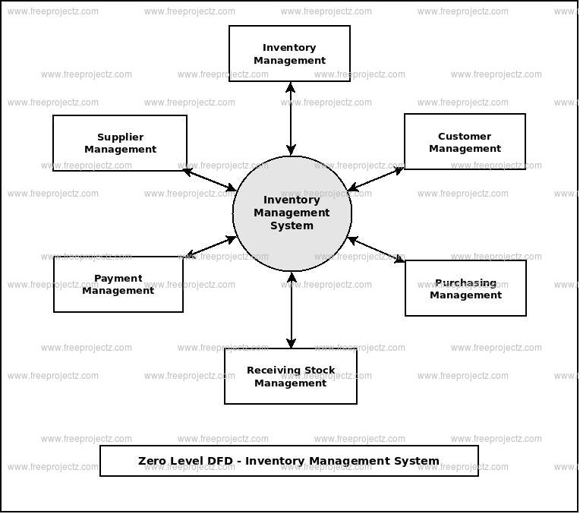

**Fig no. 2 (Zero Level DFD)**

**First Level DFD:**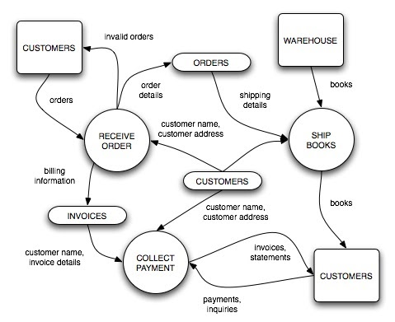

**Fig no. 3 (First Level DFD)**

**Software Requirement**

**Name of component Specification**

**Language** HTML, CSS, JavaScript, PHP, jQuery

**Browser** Any of Mozilla, Opera, Chrome etc.

**Hardware Requirements:**

**Name of component Specification**

**RAM** 128 MB

**Monitor** 15” colour monitor

**3.5 SYSTEM ANALYSIS:**

System analysis is a process of gathering and interpreting facts, diagnosing problems and the information about the Inventory Management System to recommend improvements on the system. It is a problem-solving activity that requires intensive communication between the system users and system developers. System analysis or study is an important phase of any system development process. The system is studied to the minutes detail and analysed. The system analyst plays the role of the interrogator and dwells deep into the working of the present system. The system is viewed as a whole and the input to the system are identified. The outputs from the organizations are traced to the various processes.

System analysis is concerned with becoming aware of the problem, identifying the relevant and decisional variables, analysing and synthesizing the various factors and determining an optimal or at least a satisfactory solution or program of action. A detailed study of the process must be made by various techniques like interviews, questionnaires etc. The data collected by these sources must be scrutinized to arrive to a conclusion. The conclusion is an understanding of how the system functions. This system is called the existing system. Now the existing system is subjected to close study and problem areas are identified. The designer now functions as a problem solver and tries to sort out the difficulties that the enterprise faces. The solutions are given as proposals. The proposal is then weighed with the existing system analytically and the best one is selected. The proposal is presented to the user for an endorsement by the user.

The proposal is reviewed on user request and suitable changes are made. This is loop that ends as soon as the user is satisfied with proposal. Preliminary study is the process of gathering and interpreting facts, using the information for further studies on the system. Preliminary study is problem solving activity that requires intensive communication between the system users and system developers.

**CHAPTER 4**

**CODES AND SCREENSHOTS**

**LOGIN.PHP**

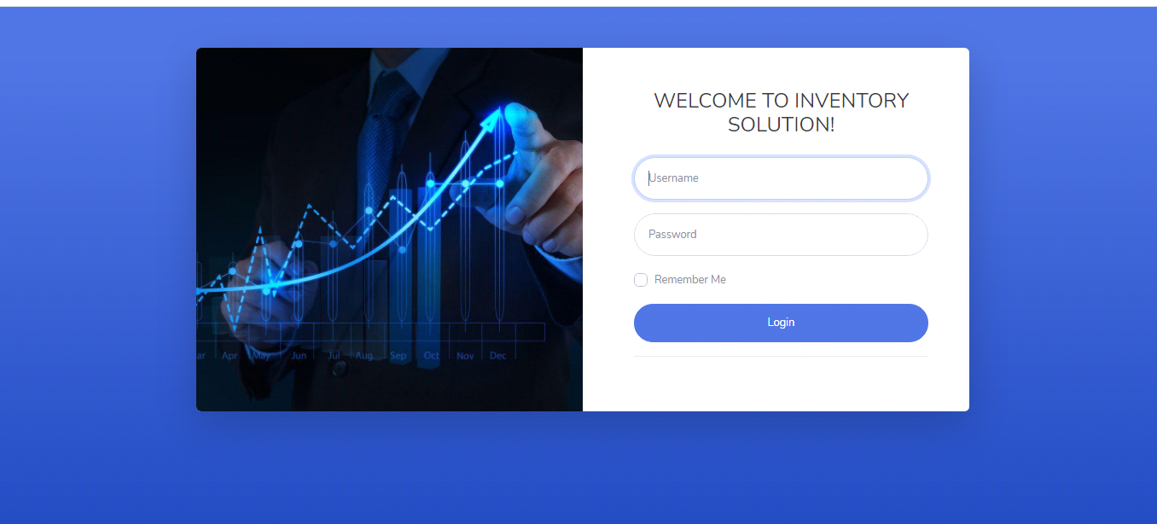

Fig no. 4 (Login Page)

<?php require('session.php');?>

<?php if(logged_in()){ ?>

<script type="text/javascript">

window.location = "index.php";

</script>

<?php

} ?>

<!DOCTYPE html>

<html lang="en">

<head>

<meta charset="utf-8">

<meta http-equiv="X-UA-Compatible" content="IE=edge">

<meta name="viewport" content="width=device-width, initial-scale=1, shrink-to-fit=no">

<meta name="description" content="">

<meta name="author" content="">

<title>INVENTORY & PURCHASE SOLUTION</title>

<!-- Custom fonts for this template-->

<link href="../vendor/fontawesome-free/css/all.min.css" rel="stylesheet" type="text/css">

<link href="https://fonts.googleapis.com/css?family=Nunito:200,200i,300,300i,400,400i,600,600i,700,700i,800,800i,900,900i" rel="stylesheet">

<!-- Custom styles for this template-->

<link href="../css/sb-admin-2.min.css" rel="stylesheet">

</head>

<body class="bg-gradient-primary">

<div class="container">

<!-- Outer Row -->

<div class="row justify-content-center">

<div class="col-xl-10 col-lg-12 col-md-9">

<div class="card o-hidden border-0 shadow-lg my-5">

<div class="card-body p-0">

<!-- Nested Row within Card Body -->

<div class="row shadow">

<div class="col-lg-6 d-none d-lg-block bg-login-image"></div>

<div class="col-lg-6">

<div class="p-5">

<div class="text-center">

<h1 class="h4 text-gray-900 mb-4">WELCOME TO INVENTORY SOLUTION!</h1>

</div>

<form class="user" role="form" action="processlogin.php" method="post">

<div class="form-group">

<input class="form-control form-control-user" placeholder="Username" name="user" type="text" autofocus>

</div>

<div class="form-group">

<input class="form-control form-control-user" placeholder="Password" name="password" type="password" value="">

</div>

<div class="form-group">

<div class="custom-control custom-checkbox small">

<input type="checkbox" class="custom-control-input" id="customCheck">

<label class="custom-control-label" for="customCheck">Remember Me</label>

</div>

</div>

<button class="btn btn-primary btn-user btn-block" type="submit" name="btnlogin">Login</button>

<hr>

<!-- <div class="text-center">

<a class="small" href="register.php">Create an Account!</a>

</div> -->

</form>

</div>

</div>

</div>

</div>

</div>

</div>

</div>

</div>

<!-- Bootstrap core JavaScript-->

<script src="../vendor/jquery/jquery.min.js"></script>

<script src="../vendor/bootstrap/js/bootstrap.bundle.min.js"></script>

<!-- Core plugin JavaScript-->

<script src="../vendor/jquery-easing/jquery.easing.min.js"></script>

<!-- Custom scripts for all pages-->

<script src="../js/sb-admin-2.min.js"></script>

</body>

</html>

**INDEX.PHP**

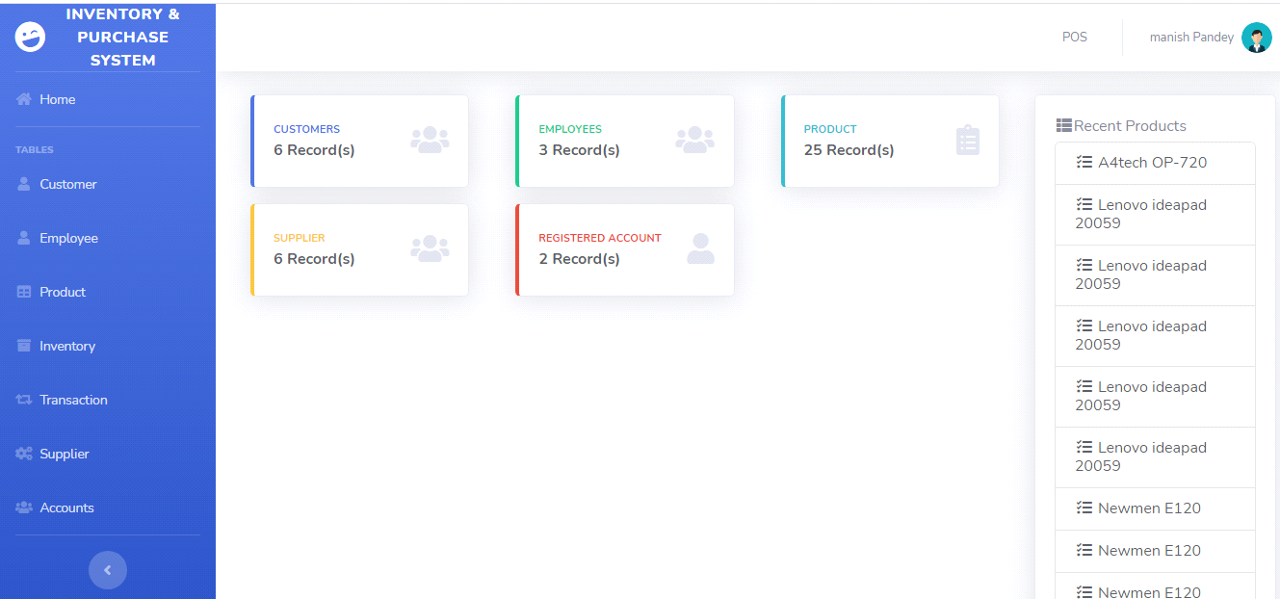

Fig no. 5 (Index Page)

<?php

include'../includes/connection.php';

include'../includes/sidebar.php';

?><?php

$query = 'SELECT ID, t.TYPE

FROM users u

JOIN type t ON t.TYPE_ID=u.TYPE_ID WHERE ID = '.$_SESSION['MEMBER_ID'].'';

$result = mysqli_query($db, $query) or die (mysqli_error($db));

while ($row = mysqli_fetch_assoc($result)) {

$Aa = $row['TYPE'];

if ($Aa=='User'){

?> <script type="text/javascript">

//then it will be redirected

alert("Restricted Page! You will be redirected to POS");

window.location = "pos.php";

</script>

<?php }

}

?>

<div class="row show-grid">

<!-- Customer ROW -->

<div class="col-md-3">

<!-- Customer record -->

<div class="col-md-12 mb-3">

<div class="card border-left-primary shadow h-100 py-2">

<div class="card-body">

<div class="row no-gutters align-items-center">

<div class="col mr-0">

<div class="text-xs font-weight-bold text-primary text-uppercase mb-1">Customers</div>

<div class="h6 mb-0 font-weight-bold text-gray-800">

<?php

$query = "SELECT COUNT(*) FROM customer";

$result = mysqli_query($db, $query) or die(mysqli_error($db));

while ($row = mysqli_fetch_array($result)) {

echo "$row[0]";

}

?> Record(s)

</div>

</div>

<div class="col-auto">

<i class="fas fa-users fa-2x text-gray-300"></i>

</div>

</div>

</div>

</div>

</div>

<!-- Supplier record -->

<div class="col-md-12 mb-3">

<div class="card border-left-warning shadow h-100 py-2">

<div class="card-body">

<div class="row no-gutters align-items-center">

<div class="col mr-0">

<div class="text-xs font-weight-bold text-warning text-uppercase mb-1">Supplier</div>

<div class="h6 mb-0 font-weight-bold text-gray-800">

<?php

$query = "SELECT COUNT(*) FROM supplier";

$result = mysqli_query($db, $query) or die(mysqli_error($db));

while ($row = mysqli_fetch_array($result)) {

echo "$row[0]";

}

?> Record(s)

</div>

</div>

<div class="col-auto">

<i class="fas fa-users fa-2x text-gray-300"></i>

</div>

</div>

</div>

</div>

</div>

</div>

<!-- Employee ROW -->

<div class="col-md-3">

<!-- Employee record -->

<div class="col-md-12 mb-3">

<div class="card border-left-success shadow h-100 py-2">

<div class="card-body">

<div class="row no-gutters align-items-center">

<div class="col mr-0">

<div class="text-xs font-weight-bold text-success text-uppercase mb-1">Employees</div>

<div class="h6 mb-0 font-weight-bold text-gray-800">

<?php

$query = "SELECT COUNT(*) FROM employee";

$result = mysqli_query($db, $query) or die(mysqli_error($db));

while ($row = mysqli_fetch_array($result)) {

echo "$row[0]";

}

?> Record(s)

</div>

</div>

<div class="col-auto">

<i class="fas fa-users fa-2x text-gray-300"></i>

</div>

</div>

</div>

</div>

</div>

<!-- User record -->

<div class="col-md-12 mb-3">

<div class="card border-left-danger shadow h-100 py-2">

<div class="card-body">

<div class="row no-gutters align-items-center">

<div class="col mr-0">

<div class="text-xs font-weight-bold text-danger text-uppercase mb-1">Registered Account</div>

<div class="h6 mb-0 font-weight-bold text-gray-800">

<?php

$query = "SELECT COUNT(*) FROM users WHERE TYPE_ID=2";

$result = mysqli_query($db, $query) or die(mysqli_error($db));

while ($row = mysqli_fetch_array($result)) {

echo "$row[0]";

}

?> Record(s)

</div>

</div>

<div class="col-auto">

<i class="fas fa-user fa-2x text-gray-300"></i>

</div>

</div>

</div>

</div>

</div>

</div>

<!-- PRODUCTS ROW -->

<div class="col-md-3">

<!-- Product record -->

<div class="col-md-12 mb-3">

<div class="card border-left-info shadow h-100 py-2">

<div class="card-body">

<div class="row no-gutters align-items-center">

<div class="col mr-0">

<div class="text-xs font-weight-bold text-info text-uppercase mb-1">Product</div>

<div class="row no-gutters align-items-center">

<div class="col-auto">

<div class="h6 mb-0 mr-3 font-weight-bold text-gray-800">

<?php

$query = "SELECT COUNT(*) FROM product";

$result = mysqli_query($db, $query) or die(mysqli_error($db));

while ($row = mysqli_fetch_array($result)) {

echo "$row[0]";

}

?> Record(s)

</div>

</div>

</div>

</div>

<div class="col-auto">

<i class="fas fa-clipboard-list fa-2x text-gray-300"></i>

</div>

</div>

</div>

</div>

</div>

</div>

<!-- RECENT PRODUCTS -->

<div class="col-lg-3">

<div class="card shadow h-100">

<div class="card-body">

<div class="row no-gutters align-items-center">

<div class="col-auto">

<i class="fa fa-th-list fa-fw"></i>

</div>

<div class="panel-heading"> Recent Products

</div>

<div class="row no-gutters align-items-center mt-1">

<div class="col-auto">

<div class="h6 mb-0 mr-0 text-gray-800">

<!-- /.panel-heading -->

<div class="panel-body">

<div class="list-group">

<?php

$query = "SELECT NAME, PRODUCT_CODE FROM product order by PRODUCT_ID DESC LIMIT 10";

$result = mysqli_query($db, $query) or die(mysqli_error($db));

while ($row = mysqli_fetch_array($result)) {

echo "<a href='#' class='list-group-item text-gray-800'>

<i class='fa fa-tasks fa-fw'></i> $row[0]

</a>";

}

?>

</div>

<!-- /.list-group -->

<a href="product.php" class="btn btn-default btn-block">View All Products</a>

</div>

<!-- /.panel-body -->

</div></div></div></div></div></div>

<!--

<div class="col-md-3">

<div class="col-md-12 mb-2">

<div class="card border-left-danger shadow h-100 py-2">

<div class="card-body">

<div class="row no-gutters align-items-center">

<div class="col mr-2">

<div class="text-xs font-weight-bold text-danger text-uppercase mb-1"><i class="fas fa-list text-danger">&nbsp;&nbsp;&nbsp;</i>Recent Products</div>

<div class="h6 mb-0 font-weight-bold text-gray-800">

<?php

$query = "SELECT NAME FROM product order by PRODUCT_ID DESC LIMIT 10";

$result = mysqli_query($db, $query) or die(mysqli_error($db));

while ($row = mysqli_fetch_array($result)) {

echo "<ul style='list-style-position: outside'>";

echo "<li>$row[0]</li>";

echo "</ul>";

}

?>

</div>

</div>

<div class="col-auto">

</div>

</div>

</div>

</div>

</div>

</div> -->

</div>

<?php

include'../includes/footer.php';

?>

**INVENTORY.PHP**

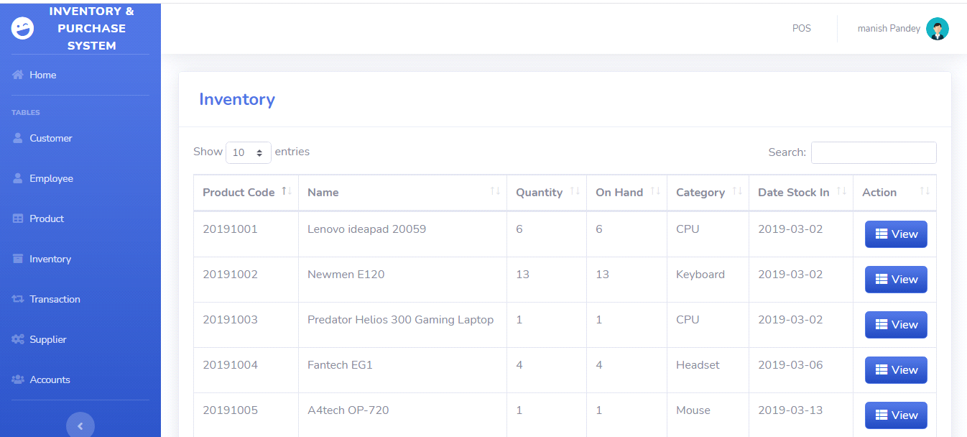

**Fig no. 6 (Inventory Page)**

<?php

include'../includes/connection.php';

include'../includes/sidebar.php';

$query = 'SELECT ID, t.TYPE

FROM users u

JOIN type t ON t.TYPE_ID=u.TYPE_ID WHERE ID = '.$_SESSION['MEMBER_ID'].'';

$result = mysqli_query($db, $query) or die (mysqli_error($db));

while ($row = mysqli_fetch_assoc($result)) {

$Aa = $row['TYPE'];

if ($Aa=='User')

?>

<script type="text/javascript">

//then it will be redirected

alert("Restricted Page! You will be redirected to POS");

window.location = "pos.php";

</script>

<?php

}

}

?>

<div class="card shadow mb-4">

<div class="card-header py-3">

<h4 class="m-2 font-weight-bold text-primary">Inventory</h4>

</div>

<div class="card-body">

<div class="table-responsive">

<table class="table table-bordered" id="dataTable" width="100%" cellspacing="0">

<thead>

<tr>

<th>Product Code</th>

<th>Name</th>

<th>Quantity</th>

<th>On Hand</th>

<th>Category</th>

<th>Date Stock In</th>

<th>Action</th>

</tr>

</thead>

<tbody>

<?php

$query = 'SELECT PRODUCT_ID, PRODUCT_CODE, NAME, COUNT(`QTY_STOCK`) AS "QTY_STOCK", COUNT(`ON_HAND`) AS "ON_HAND", CNAME, DATE_STOCK_IN FROM product p join category c on p.CATEGORY_ID=c.CATEGORY_ID GROUP BY PRODUCT_CODE';

$result = mysqli_query($db, $query) or die (mysqli_error($db));

while ($row = mysqli_fetch_assoc($result)) {

echo '<tr>';

echo '<td>'. $row['PRODUCT_CODE'].'</td>';

echo '<td>'. $row['CNAME'].'</td>';

echo '<td>'. $row['DATE_STOCK_IN'].'</td>';

echo '<td align="right">

<a type="button" class="btn btn-primary bg-gradient-primary" href="inv_searchfrm.php?action=edit & id='.$row['PRODUCT_CODE'] . '"><i class="fas fa-fw fa-th-list"></i> View</a>

</div> </td>';

echo '</tr> ';

}

?>

</tbody>

</table>

</div>

</div>

</div>

<?php

include'../includes/footer.php';

?>

**POS.PHP**

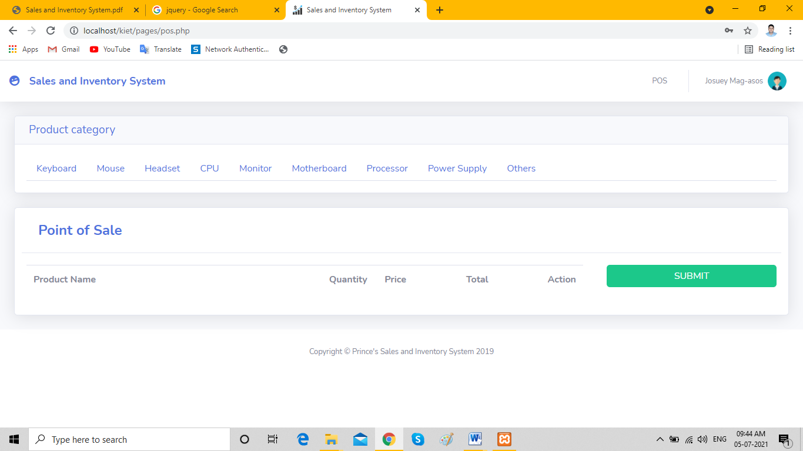

**Fig no. 7 (Point of Sale)**

<?php

include'../includes/connection.php';

include'../includes/topp.php';

// session_start();

$product_ids = array();

//session_destroy();

//check if Add to Cart button has been submitted

if(filter_input(INPUT_POST, 'addpos')){

if(isset($_SESSION['pointofsale'])){

//keep track of how mnay products are in the shopping cart

$count = count($_SESSION['pointofsale']);

//create sequantial array for matching array keys to products id's

$product_ids = array_column($_SESSION['pointofsale'], 'id');

if (!in_array(filter_input(INPUT_GET, 'id'), $product_ids)){

$_SESSION['pointofsale'][$count] = array

(

'id' => filter_input(INPUT_GET, 'id'),

'name' => filter_input(INPUT_POST, 'name'),

'price' => filter_input(INPUT_POST, 'price'),

'quantity' => filter_input(INPUT_POST, 'quantity')

);

}

else { //product already exists, increase quantity

//match array key to id of the product being added to the cart

for ($i = 0; $i < count($product_ids); $i++){

if ($product_ids[$i] == filter_input(INPUT_GET, 'id')){

//add item quantity to the existing product in the array

$_SESSION['pointofsale'][$i]['quantity'] += filter_input(INPUT_POST, 'quantity');

}

}

}

}

else { //if shopping cart doesn't exist, create first product with array key 0

//create array using submitted form data, start from key 0 and fill it with values

$_SESSION['pointofsale'][0] = array

(

'id' => filter_input(INPUT_GET, 'id'),

'name' => filter_input(INPUT_POST, 'name'),

'price' => filter_input(INPUT_POST, 'price'),

'quantity' => filter_input(INPUT_POST, 'quantity')

);

}

}

if(filter_input(INPUT_GET, 'action') == 'delete'){

//loop through all products in the shopping cart until it matches with GET id variable

foreach($_SESSION['pointofsale'] as $key => $product){

if ($product['id'] == filter_input(INPUT_GET, 'id')){

//remove product from the shopping cart when it matches with the GET id

unset($_SESSION['pointofsale'][$key]);

}

}

//reset session array keys so they match with $product_ids numeric array

$_SESSION['pointofsale'] = array_values($_SESSION['pointofsale']);

}

//pre_r($_SESSION);

function pre_r($array){

echo '<pre>';

print_r($array);

echo '</pre>';

}

?>

<div class="row">

<div class="col-lg-12">

<div class="card shadow mb-0">

<div class="card-header py-2">

<h4 class="m-1 text-lg text-primary">Product category</h4>

</div>

<!-- /.panel-heading -->

<div class="card-body">

<!-- Nav tabs -->

<ul class="nav nav-tabs">

<li class="nav-item">

<a class="nav-link" href="#" data-target="#keyboard" data-toggle="tab">Keyboard</a>

</li>

<li class="nav-item">

<a class="nav-link" href="#" data-target="#mouse" data-toggle="tab">Mouse</a>

</li>

<li class="nav-item">

<a class="nav-link" href="#headset" data-toggle="tab">Headset</a>

</li>

<li class="nav-item">

<a class="nav-link" href="#cpu" data-toggle="tab">CPU</a>

</li>

<li class="nav-item">

<a class="nav-link" href="#monitor" data-toggle="tab">Monitor</a>

</li>

<li class="nav-item">

<a class="nav-link" href="#motherboard" data-toggle="tab">Motherboard</a>

</li>

<li class="nav-item">

<a class="nav-link" href="#processor" data-toggle="tab">Processor</a>

</li>

<li class="nav-item">

<a class="nav-link" href="#powersupply" data-toggle="tab">Power Supply</a>

</li>

<li class="nav-item">

<a class="nav-link" href="#others" data-toggle="tab">Others</a>

</li>

</ul>

<!-- TAB PANE AREA - ANG UNOD KA TABS ARA SA TABPANE.PHP -->

<?php include 'postabpane.php'; ?>

<!-- END TAB PANE AREA - ANG UNOD KA TABS ARA SA TABPANE.PHP -->

<div style="clear:both"></div>

<br />

<div class="card shadow mb-4 col-md-12">

<div class="card-header py-3 bg-white">

<h4 class="m-2 font-weight-bold text-primary">Point of Sale</h4>

</div>

<div class="row">

<div class="card-body col-md-9">

<div class="table-responsive">

<!-- trial form lang -->

<form role="form" method="post" action="pos_transac.php?action=add">

<input type="hidden" name="employee" value="<?php echo $_SESSION['FIRST_NAME']; ?>">

<input type="hidden" name="role" value="<?php echo $_SESSION['JOB_TITLE']; ?>">

<table class="table">

<tr>

<th width="55%">Product Name</th>

<th width="10%">Quantity</th>

<th width="15%">Price</th>

<th width="15%">Total</th>

<th width="5%">Action</th>

</tr>

<?php

if(!empty($_SESSION['pointofsale'])):

$total = 0;

foreach($_SESSION['pointofsale'] as $key => $product):

?>

<tr>

<td>

<input type="hidden" name="name[]" value="<?php echo $product['name']; ?>">

<?php echo $product['name']; ?>

</td>

<td>

<input type="hidden" name="quantity[]" value="<?php echo $product['quantity']; ?>">

<?php echo $product['quantity']; ?>

</td>

<td>

<input type="hidden" name="price[]" value="<?php echo $product['price']; ?>">

₹ <?php echo number_format($product['price']); ?>

</td>

<td>

<input type="hidden" name="total" value="<?php echo $product['quantity'] * $product['price']; ?>">

₹ <?php echo number_format($product['quantity'] * $product['price'], 2); ?></td>

<td>

<a href="pos.php?action=delete&id=<?php echo $product['id']; ?>">

<div class="btn bg-gradient-danger btn-danger"><i class="fas fa-fw fa-trash"></i></div>

</a>

</td>

</tr>

<?php

$total = $total + ($product['quantity'] * $product['price']);

endforeach;

?>

<?php

endif;

?>

</table>

</div>

</div>

<?php

include 'posside.php';

include'../includes/footer.php';

?>

**PRODUCT.PHP**

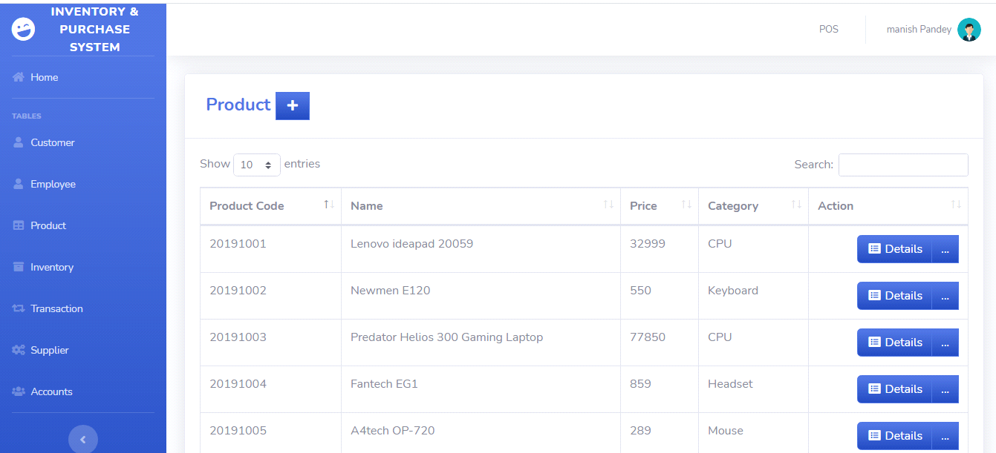 **Fig no. 8 (Product list)**

<?php

include'../includes/connection.php';

include'../includes/sidebar.php';

$query = 'SELECT ID, t.TYPE

FROM users u

JOIN type t ON t.TYPE_ID=u.TYPE_ID WHERE ID = '.$_SESSION['MEMBER_ID'].'';

$result = mysqli_query($db, $query) or die (mysqli_error($db));

while ($row = mysqli_fetch_assoc($result)) {

$Aa = $row['TYPE'];

if ($Aa=='User'){

?>

<script type="text/javascript">

//then it will be redirected

alert("Restricted Page! You will be redirected to POS");

window.location = "pos.php";

</script>

<?php

}

}

$sql = "SELECT DISTINCT CNAME, CATEGORY_ID FROM category order by CNAME asc";

$result = mysqli_query($db, $sql) or die ("Bad SQL: $sql");

$aaa = "<select class='form-control' name='category' required>

<option disabled selected hidden>Select Category</option>";

while ($row = mysqli_fetch_assoc($result)) {

$aaa .= "<option value='".$row['CATEGORY_ID']."'>".$row['CNAME']."</option>";

}

$aaa .= "</select>";

$sql2 = "SELECT DISTINCT SUPPLIER_ID, COMPANY_NAME FROM supplier order by COMPANY_NAME asc";

$result2 = mysqli_query($db, $sql2) or die ("Bad SQL: $sql2");

$sup = "<select class='form-control' name='supplier' required>

<option disabled selected hidden>Select Supplier</option>";

while ($row = mysqli_fetch_assoc($result2)) {

$sup .= "<option value='".$row['SUPPLIER_ID']."'>".$row['COMPANY_NAME']."</option>";

}

$sup .= "</select>";

?>

<div class="card shadow mb-4">

<div class="card-header py-3">

<h4 class="m-2 font-weight-bold text-primary">Product&nbsp;<a href="#" data-toggle="modal" data-target="#aModal" type="button" class="btn btn-primary bg-gradient-primary" style="border-radius: 0px;"><i class="fas fa-fw fa-plus"></i></a></h4>

</div>

<div class="card-body">

<div class="table-responsive">

<table class="table table-bordered" id="dataTable" width="100%"

cellspacing="0">

<thead>

<tr>

<th>Product Code</th>

<th>Name</th>

<th>Price</th>

<th>Category</th>

<th>Action</th>

</tr>

</thead>

<tbody>

<?php

$query = 'SELECT PRODUCT_ID, PRODUCT_CODE, NAME, PRICE, CNAME, DATE_STOCK_IN FROM product p join category c on p.CATEGORY_ID=c.CATEGORY_ID GROUP BY PRODUCT_CODE';

$result = mysqli_query($db, $query) or die (mysqli_error($db));

while ($row = mysqli_fetch_assoc($result)) {

echo '<tr>';

echo '<td>'. $row['PRODUCT_CODE'].'</td>';

echo '<td>'. $row['NAME'].'</td>';

echo '<td>'. $row['PRICE'].'</td>';

echo '<td>'. $row['CNAME'].'</td>';

echo '<td align="right"> <div class="btn-group">

<a type="button" class="btn btn-primary bg-gradient-primary" href="pro_searchfrm.php?action=edit & id='.$row['PRODUCT_CODE'] . '"><i class="fas fa-fw fa-list-alt"></i> Details</a>

<div class="btn-group">

<a type="button" class="btn btn-primary bg-gradient-primary dropdown no-arrow" data-toggle="dropdown" style="color:white;">

... <span class="caret"></span></a>

<ul class="dropdown-menu text-center" role="menu">

<li>

<a type="button" class="btn btn-warning bg-gradient-warning btn-block" style="border-radius: 0px;" href="pro_edit.php?action=edit & id='.$row['PRODUCT_ID']. '">

<i class="fas fa-fw fa-edit"></i> Edit

</a>

</li>

</ul>

</div>

</div> </td>';

echo '</tr> ';

}

?>

</tbody>

</table>

</div>

</div>

</div>

<?php

include'../includes/footer.php';

?>

<!-- Product Modal-->

<div class="modal fade" id="aModal" tabindex="-1" role="dialog" aria-labelledby="exampleModalLabel" aria-hidden="true">

<div class="modal-dialog" role="document">

<div class="modal-content">

<div class="modal-header">

<h5 class="modal-title" id="exampleModalLabel">Add Product</h5>

<button class="close" type="button" data-dismiss="modal" aria-label="Close">

<span aria-hidden="true">×</span>

</button>

</div>

<div class="modal-body">

<form role="form" method="post" action="pro_transac.php?action=add">

<div class="form-group">

<input class="form-control" placeholder="Product Code" name="prodcode" required>

</div>

<div class="form-group">

<input class="form-control" placeholder="Name" name="name" required>

</div>

<div class="form-group">

<textarea rows="5" cols="50" texarea" class="form-control" placeholder="Description" name="description" required></textarea>

</div>

<div class="form-group">

<input type="number" min="1" max="999999999" class="form-control" placeholder="Quantity" name="quantity" required>

</div>

<div class="form-group">

<input type="number" min="1" max="999999999" class="form-control" placeholder="On Hand" name="onhand" required>

</div>

<div class="form-group">

<input type="number" min="1" max="9999999999" class="form-control" placeholder="Price" name="price" required>

</div>

<div class="form-group">

<?php

echo $aaa;

?>

</div>

<div class="form-group">

<?php

echo $sup;

?>

</div>

<div class="form-group">

<input type="text" onfocus="(this.type='date')" onblur="(this.type='text')" class="form-control" placeholder="Date Stock In" name="datestock" required>

</div>

<hr>

<button type="submit" class="btn btn-success"><i class="fa fa-check fa-fw"></i>Save</button>

<button type="reset" class="btn btn-danger"><i class="fa fa-times fa-fw"></i>Reset</button>

<button class="btn btn-secondary" type="button" data-dismiss="modal">Cancel</button>

</form>

</div>

</div>

</div>

</div>

**SUPPLIER.PHP**

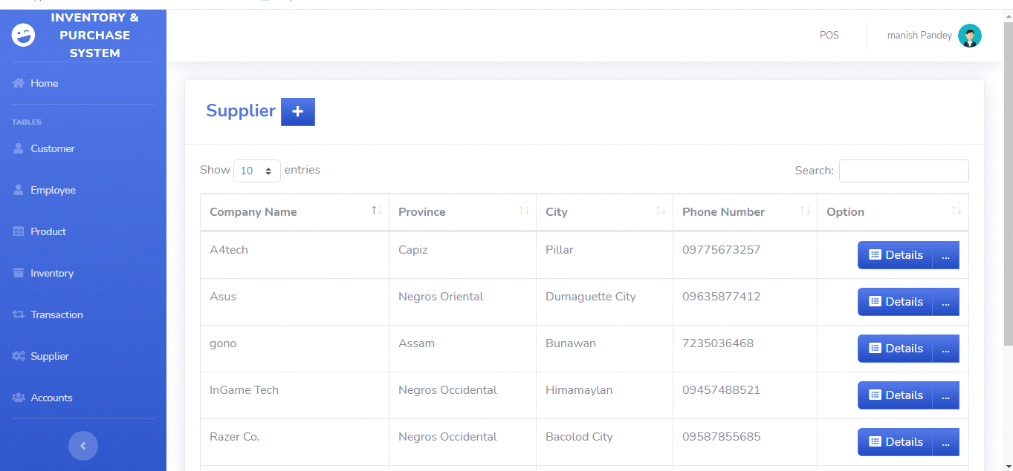 **Fig no. 9 (Supplier page)**

<?php

include'../includes/connection.php';

include'../includes/sidebar.php';

$query = 'SELECT ID, t.TYPE

FROM users u

JOIN type t ON t.TYPE_ID=u.TYPE_ID WHERE ID = '.$_SESSION['MEMBER_ID'].'';

$result = mysqli_query($db, $query) or die (mysqli_error($db));

while ($row = mysqli_fetch_assoc($result)) {

$Aa = $row['TYPE'];

if ($Aa=='User'){

?>

<script type="text/javascript">

//then it will be redirected

alert("Restricted Page! You will be redirected to POS");

window.location = "pos.php";

</script>

<?php

}

}

?>

<div class="card shadow mb-4">

<div class="card-header py-3">

<h4 class="m-2 font-weight-bold text-primary">Supplier&nbsp;<a href="#" data-toggle="modal" data-target="#supplierModal" type="button" class="btn btn-primary bg-gradient-primary" style="border-radius: 0px;"><i class="fas fa-fw fa-plus"></i></a></h4>

</div>

<div class="card-body">

<div class="table-responsive">

<table class="table table-bordered" id="dataTable" width="100%" cellspacing="0">

<thead>

<tr>

<th>Company Name</th>

<th>Province</th>

<th>City</th>

<th>Phone Number</th>

<th>Option</th>

</tr>

</thead>

<tbody>

<?php

$query = 'SELECT SUPPLIER_ID, COMPANY_NAME, l.PROVINCE, l.CITY, PHONE_NUMBER FROM supplier s join location l on s.LOCATION_ID=l.LOCATION_ID';

$result = mysqli_query($db, $query) or die (mysqli_error($db));

while ($row = mysqli_fetch_assoc($result)) {

echo '<tr>';

echo '<td>'. $row['COMPANY_NAME'].'</td>';

echo '<td>'. $row['PROVINCE'].'</td>';

echo '<td>'. $row['CITY'].'</td>';

echo '<td>'. $row['PHONE_NUMBER'].'</td>';

echo '<td align="right"> <div class="btn-group">

<a type="button" class="btn btn-primary bg-gradient-primary" href="sup_searchfrm.php?action=edit & id='.$row['SUPPLIER_ID'] . '"><i class="fas fa-fw fa-list-alt"></i> Details</a>

<div class="btn-group">

<a type="button" class="btn btn-primary bg-gradient-primary dropdown no-arrow" data-toggle="dropdown" style="color:white;">

... <span class="caret"></span></a>

<ul class="dropdown-menu text-center" role="menu">

<li>

<a type="button" class="btn btn-warning bg-gradient-warning btn-block" style="border-radius: 0px;" href="sup_edit.php?action=edit & id='.$row['SUPPLIER_ID']. '">

<i class="fas fa-fw fa-edit"></i> Edit

</a>

</li>

</ul>

</div>

</div> </td>';

echo '</tr> ';

}

?>

</tbody>

</table>

</div>

</div>

</div>

<!-- Customer Modal-->

<div class="modal fade" id="supplierModal" tabindex="-1" role="dialog" aria-labelledby="exampleModalLabel" aria-hidden="true">

<div class="modal-dialog" role="document">

<div class="modal-content">

<div class="modal-header">

<h5 class="modal-title" id="exampleModalLabel">Add Supplier</h5>

<button class="close" type="button" data-dismiss="modal" aria-label="Close">

<span aria-hidden="true">×</span>

</button>

</div>

<div class="modal-body">

<form role="form" method="post" action="sup_transac.php?action=add">

<div class="form-group">

<input class="form-control" placeholder="Company Name" name="companyname" required>

</div>

<div class="form-group">

<select class="form-control" id="province" placeholder="Province" name="province" required></select>

</div>

<div class="form-group">

<select class="form-control" id="city" placeholder="City" name="city" required></select>

</div>

<div class="form-group">

<input class="form-control" placeholder="Phone Number" name="phonenumber" required>

</div>

<hr>

<button type="submit" class="btn btn-success"><i class="fa fa-check fa-fw"></i>Save</button>

<button type="reset" class="btn btn-danger"><i class="fa fa-times fa-fw"></i>Reset</button>

<button class="btn btn-secondary" type="button" data-dismiss="modal">Cancel</button>

</form>

</div>

</div>

</div>

</div>

<?php

include'../includes/footer.php';

?>

**Transaction.php**

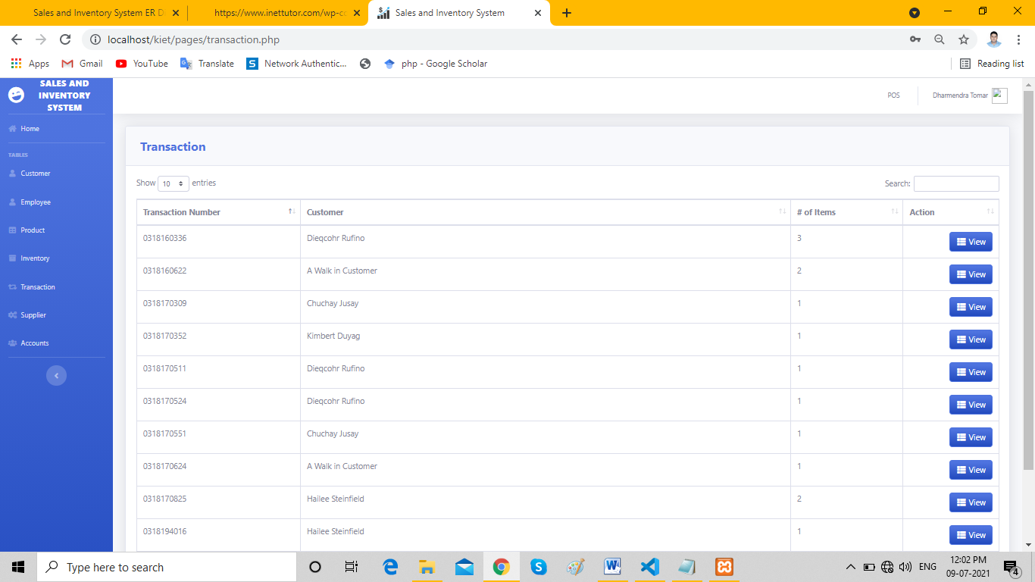

**Fig no. 10 (Transection Page)**

<?php

include'../includes/connection.php';

include'../includes/sidebar.php';

$query = 'SELECT ID, t.TYPE

FROM users u

JOIN type t ON t.TYPE_ID=u.TYPE_ID WHERE ID = '.$_SESSION['MEMBER_ID'].'';

$result = mysqli_query($db, $query) or die (mysqli_error($db));

while ($row = mysqli_fetch_assoc($result)) {

$Aa = $row['TYPE'];

if ($Aa=='User'){

?>

<script type="text/javascript">

//then it will be redirected

alert("Restricted Page! You will be redirected to POS");

window.location = "pos.php";

</script>

<?php

}

}

?>

<div class="card shadow mb-4">

<div class="card-header py-3">

<h4 class="m-2 font-weight-bold text-primary">Transaction</h4>

</div>

<div class="card-body">

<div class="table-responsive">

<table class="table table-bordered" id="dataTable" width="100%" cellspacing="0">

<thead>

<tr>

<th width="19%">Transaction Number</th>

<th>Customer</th>

<th width="13%"># of Items</th>

<th width="11%">Action</th>

</tr>

</thead>

<tbody>

<?php

$query = 'SELECT *, FIRST_NAME, LAST_NAME

FROM transaction T

JOIN customer C ON T.`CUST_ID`=C.`CUST_ID`

ORDER BY TRANS_D_ID ASC';

$result = mysqli_query($db, $query) or die (mysqli_error($db));

while ($row = mysqli_fetch_assoc($result)) {

echo '<tr>';

echo '<td>'. $row['TRANS_D_ID'].'</td>';

echo '<td>'. $row['FIRST_NAME'].' '. $row['LAST_NAME'].'</td>';

echo '<td>'. $row['NUMOFITEMS'].'</td>';

echo '<td align="right">

<a type="button" class="btn btn-primary bg-gradient-primary" href="trans_view.php?action=edit & id='.$row['TRANS_ID'] . '"><i class="fas fa-fw fa-th-list"></i> View</a>

</div> </td>';

echo '</tr> ';

}

?>

</tbody>

</table>

</div>

</div>

</div>

<?php

include'../includes/footer.php';

?>

**CUSTOMER.PHP**

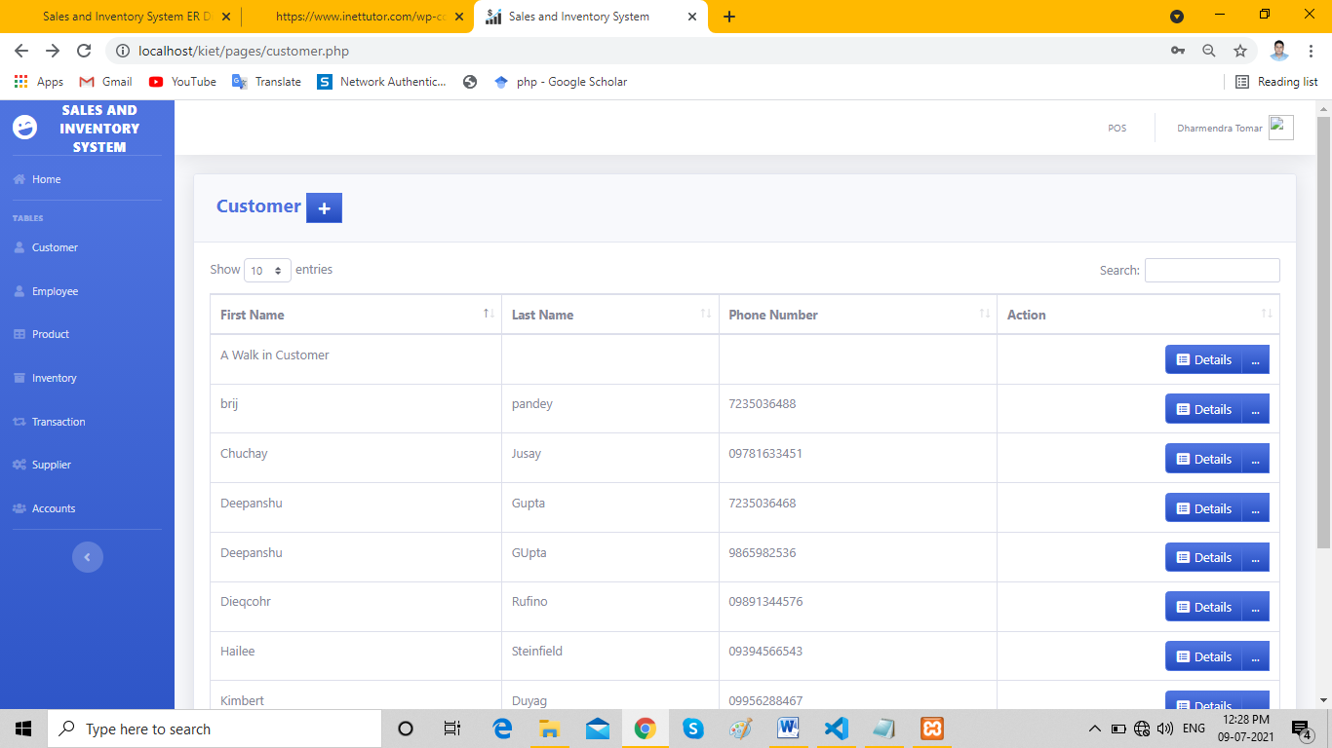

**Fig no. 11 (Customer List)**

<?php

include'../includes/connection.php';

include'../includes/sidebar.php';

?><?php

$query = 'SELECT ID, t.TYPE

FROM users u

JOIN type t ON t.TYPE_ID=u.TYPE_ID WHERE ID = '.$_SESSION['MEMBER_ID'].'';

$result = mysqli_query($db, $query) or die (mysqli_error($db));

while ($row = mysqli_fetch_assoc($result)) {

$Aa = $row['TYPE'];

if ($Aa=='User'){

?> <script type="text/javascript">

//then it will be redirected

alert("Restricted Page! You will be redirected to POS");

window.location = "pos.php";

</script>

<?php }

}

?>

<div class="card shadow mb-4">

<div class="card-header py-3">

<h4 class="m-2 font-weight-bold text-primary">Customer&nbsp;<a href="#" data-toggle="modal" data-target="#customerModal" type="button" class="btn btn-primary bg-gradient-primary" style="border-radius: 0px;"><i class="fas fa-fw fa-plus"></i></a></h4>

</div>

<div class="card-body">

<div class="table-responsive">

<table class="table table-bordered" id="dataTable" width="100%" cellspacing="0">

<thead>

<tr>

<th>First Name</th>

<th>Last Name</th>

<th>Phone Number</th>

<th>Action</th>

</tr>

</thead>

<tbody>

<?php

$query = 'SELECT * FROM customer';

$result = mysqli_query($db, $query) or die (mysqli_error($db));

while ($row = mysqli_fetch_assoc($result)) {

echo '<tr>';

echo '<td>'. $row['FIRST_NAME'].'</td>';

echo '<td>'. $row['LAST_NAME'].'</td>';

echo '<td>'. $row['PHONE_NUMBER'].'</td>';

echo '<td align="right"> <div class="btn-group">

<a type="button" class="btn btn-primary bg-gradient-primary" href="cust_searchfrm.php?action=edit & id='.$row['CUST_ID'] . '"><i class="fas fa-fw fa-list-alt"></i> Details</a>

<div class="btn-group">

<a type="button" class="btn btn-primary bg-gradient-primary dropdown no-arrow" data-toggle="dropdown" style="color:white;">

... <span class="caret"></span></a>

<ul class="dropdown-menu text-center" role="menu">

<li>

<a type="button" class="btn btn-warning bg-gradient-warning btn-block" style="border-radius: 0px;" href="cust_edit.php?action=edit & id='.$row['CUST_ID']. '">

<i class="fas fa-fw fa-edit"></i> Edit

</a>

</li>

</ul>

</div>

</div> </td>';

echo '</tr> ';

}

?>

</tbody>

</table>

</div>

</div>

</div>

<?php

include'../includes/footer.php';

?>

**EMPLOYEE.PHP**

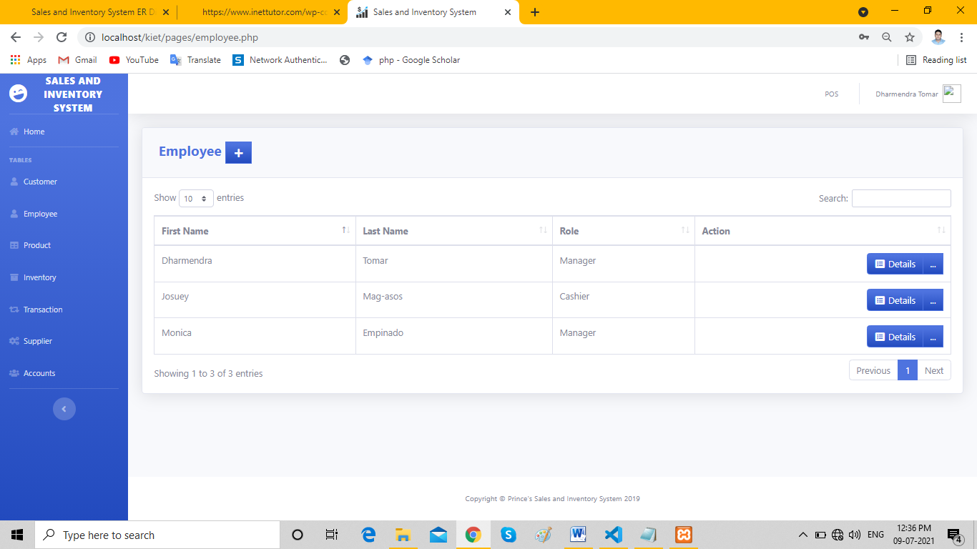

**Fig no. 12 (Employee Detail)**

<?php

include'../includes/connection.php';

include'../includes/sidebar.php';

?><?php

$query = 'SELECT ID, t.TYPE

FROM users u

JOIN type t ON t.TYPE_ID=u.TYPE_ID WHERE ID = '.$_SESSION['MEMBER_ID'].'';

$result = mysqli_query($db, $query) or die (mysqli_error($db));

while ($row = mysqli_fetch_assoc($result)) {

$Aa = $row['TYPE'];

if ($Aa=='User'){

?> <script type="text/javascript">

//then it will be redirected

alert("Restricted Page! You will be redirected to POS");

window.location = "pos.php";

</script>

<?php }

}

?>

<div class="card shadow mb-4">

<div class="card-header py-3">

<h4 class="m-2 font-weight-bold text-primary">Employee&nbsp;<a href="#" data-toggle="modal" data-target="#employeeModal" type="button" class="btn btn-primary bg-gradient-primary" style="border-radius: 0px;"><i class="fas fa-fw fa-plus"></i></a></h4>

</div>

<div class="card-body">

<div class="table-responsive">

<table class="table table-bordered" id="dataTable" width="100%" cellspacing="0">

<thead>

<tr>

<th>First Name</th>

<th>Last Name</th>

<th>Role</th>

<th>Action</th>

</tr>

</thead>

<tbody>

<?php

$query = 'SELECT EMPLOYEE_ID, FIRST_NAME, LAST_NAME, j.JOB_TITLE FROM employee e JOIN job j ON e.JOB_ID=j.JOB_ID';

$result = mysqli_query($db, $query) or die (mysqli_error($db));

while ($row = mysqli_fetch_assoc($result)) {

echo '<tr>';

echo '<td>'. $row['FIRST_NAME'].'</td>';

echo '<td>'. $row['LAST_NAME'].'</td>';

echo '<td>'. $row['JOB_TITLE'].'</td>';

echo '<td align="right"> <div class="btn-group">

<a type="button" class="btn btn-primary bg-gradient-primary" href="emp_searchfrm.php?action=edit & id='.$row['EMPLOYEE_ID'] . '"><i class="fas fa-fw fa-list-alt"></i> Details</a>

<div class="btn-group">

<a type="button" class="btn btn-primary bg-gradient-primary dropdown no-arrow" data-toggle="dropdown" style="color:white;">

... <span class="caret"></span></a>

<ul class="dropdown-menu text-center" role="menu">

<li>

<a type="button" class="btn btn-warning bg-gradient-warning btn-block" style="border-radius: 0px;" href="emp_edit.php?action=edit & id='.$row['EMPLOYEE_ID']. '">

<i class="fas fa-fw fa-edit"></i> Edit

</a>

</li>

</ul>

</div>

</div> </td>';

echo '</tr> ';

}

?>

</tbody>

</table>

</div>

</div>

</div>

<?php

include'../includes/footer.php';

?

**CHAPTER 5**

**CONCLUSION & FUTURE SCOPE**

**5.1 Future Scope of the Project**

1.Determination of economic order quantity

2. Formulation of policy

3. Determination of lead time

4. Effectiveness towards running of store

5. Organisation structure

6. Determination of safety stock

7. Minimum material handling and storage cost.

**1. Determination of economic order quantity***:*

Economic order quantity or economic lot size refers to that number ordered in a single purchase or number of units should be manufactured in a single run, so that the total costs — ordering or set up costs and inventory carrying costs are at the minimum. So, the determination of E.O.Q. is also within the scope of inventory control.

**2. Formulation of policy:**

The policies of investment procurement, storage, handling, accounting, storages and stock outs, deterioration, obsolescence etc. are to be formulated under the scientific system of inventory control. What, when and how much of purchasing and fixation of minimum and maximum levels is also to be determined for a given period of time.

**3. Determination of lead time:**

By lead time is meant the time that lapses between the raising of an indent by the stores and the receipt of materials by them. Lead time is of fundamental importance in determining inventory levels.

**4***.* **Effectiveness towards running of store***:*

The determination of policies of the location, layout and materials and storage handling equipment’s certainly help in the effective working of stores organisation.

***5*. Organisation structure:**

After determining of inventory policy, the next step is to decide the location, layout and types of storehouse. It facilitates the movement of materials and thus minimise the storage and handling cost of stores.

***6.* Determination of safety stock:**

Safety stock is defined as the difference between the amount stocked to satisfy demand during a certain time interval and the mean expected demand for that period. It is for the purpose of providing protection against depletion. If demand remained constant and lead tin-; is invariable, there would be no fear of shortages and no need for safely stocks.

The exact quantity of safety stock of an item depends upon its lead time, usage value, and variability of lead time demand, carrying charges and the importance of its stock out cost. Again, determination of buffer stock reserve stock is included in the management of inventory.

**7. Minimum material handling and storage cost:**

Stores organisation activities are arranged in such a manner that the east of bringing in the store house and issuing from the store house if the various stores, will minimise the storage and materials handling cost of stores.

**5.2**  **CONCLUSION**

To conclude, Sales and Inventory Management System is a simple desktop based application basically suitable for small organization. It has every basic item which is used for the small organization. Our team is successful in making the application where we can update, insert and delete the item as per the requirement. This application also provides a simple report on daily basis to know the daily sales and purchase details. This application matches for small organization where there small limited if Distributer’s & wholesaler. Through it has some limitations; our team strongly believes that the implementation of this system will surely benefit the organization.

The project “Sales and Inventory System for Calculation and Ordering of Available and Processed Resources” mainly as the name suggests deals with the calculation of the available and processed resources for an accurate inventory control and process management for a domain specific client who are related to the subject of food chains/outlets. This enables the inventory to be applied at every level in the hierarchy of the products and its complex combinations of recipes.

A system that accurately calculates the atomic ingredients used for making a recipe then automatically performs the back end operation pertaining to a database of many relational tables onto which the changes are being made with each and every operation performed on the front end and which also shows up if at the time of retrieval. The most important part of Inventory controlling is its ability to check for threshold levels and alert the manager to replenish the stock before it reaches a danger zone. So as when an ingredient level goes below the threshold level then it routes an alert to the manager.

Then if needed accordingly an automated order form is produced so as to each specific vendor along with the quantities needed for replenishment .As a part of the standard maintaining a drill of risk management is done in order to sustain during the days of special occasion or holidays when the demand reaches to rather more different scale as compared to other days.

These occasions call on for special inclusions into the menu which reflects on the recipes and in turn reflects the ingredients being used up eventually. Thus was provided the liberty of adding special recipe to the menu for some special occasion and is regarded as a key feature. To be able to simplify the user friendliness even more the concept of ‘prediction’ is added which enables the manager to see the past years prediction of the ingredients usage and then based on the informational analysis done on the data a prediction is then generated which would suit the requirements of the current year and then accordingly an appropriate order form is generated and then passed on to the vendor as the requirements for replenishing the stock.

* 1. **Reference’s & Bibliography**

1. Lawson, B., & Sharp, R. (2011). *Introducing html5*. New Riders.
2. Lubbers, P., Albers, B., Salim, F., & Pye, T. (2011). *Pro HTML5 programming* (pp. 107-133). New York, NY, USA:: Apress.
3. Anthes, G. (2012). HTML5 leads a web revolution. *Communications of the ACM*, *55*(7), 16-17.
4. Alawar, M. W., & Abu-Naser, S. S. (2017). CSS-Tutor: An intelligent tutoring system for CSS and HTML.
5. Duckett, J. (2011). *HTML & CSS: design and build websites* (Vol. 15). Indianapolis, IN: Wiley.
6. Ferekides, C. S., Marinskiy, D., Viswanathan, V., Tetali, B., Palekis, V., Selvaraj, P., & Morel, D. L. (2000). High efficiency CSS CdTe solar cells. *Thin Solid Films*, *361*, 520-526.
7. Guha, A., Saftoiu, C., & Krishnamurthi, S. (2010, June). The essence of JavaScript. In *European conference on Object-oriented programming* (pp. 126-150). Springer, Berlin, Heidelberg.
8. Crockford, D. (2008). *JavaScript: The Good Parts: The Good Parts*. " O'Reilly Media, Inc.".
9. Richards, G., Lebresne, S., Burg, B., & Vitek, J. (2010, June). An analysis of the dynamic behavior of JavaScript programs. In *Proceedings of the 31st ACM SIGPLAN Conference on Programming Language Design and Implementation* (pp. 1-12).
10. Draxler, R. R., & Rolph, G. D. (2010). HYSPLIT (HYbrid Single-Particle Lagrangian Integrated Trajectory) model access via NOAA ARL READY website (http://ready. arl. noaa. gov/HYSPLIT. php), NOAA Air Resources Laboratory. *Silver Spring, MD*, *25*.
11. The neurotropic properties of AAV-PHP. B are limited to C57BL/6J mice. *Molecular Therapy* arl. noaa. gov/HYSPLIT. php), NOAA Air Resources Laboratory. *Silver Spring, MD*, *25*.
12. Hordeaux, J., Wang, Q., Katz, N., Buza, E. L., Bell, P., & Wilson, J. M. (2018). The neurotropic properties of AAV-PHP. B are limited to C57BL/6J mice. *Molecular Therapy*, *26*(3), 664-668.
13. Widenius, M., Axmark, D., & Arno, K. (2002). *MySQL reference manual: documentation from the source*. " O'Reilly Media, Inc.".
14. Győrödi, C., Győrödi, R., Pecherle, G., & Olah, A. (2015, June). A comparative study: MongoDB vs. MySQL. In *2015 13th International Conference on Engineering of Modern Electric Systems (EMES)* (pp. 1-6). IEEE.
15. MySQL, A. B. (2006). *MySQL administrator's guide and language reference*. Sams Publishing.